Social Media — SQL Project:

Objective Questions
Q1 Are there any tables with duplicate or missing null values? If so, how would you handle them?
users — rows with NULL username
Output columns (in order): id, username, created_at (3 columns)
Row count: Varies — this is what O1 is asking you to determine. Run the query and report what you find.
SELECT id, username, created_at FROM users WHERE username IS NULL;
users — duplicate usernames
Output columns (in order): username, count (2 columns)
Row count: Varies — this is what O1 is asking you to determine. Run the query and report what you find.
SELECT username, COUNT(*) AS count FROM users GROUP BY username HAVING COUNT(*) > 1;
photos — rows with NULL image_url / user_id / created_dat
Output columns (in order): id, image_url, user_id, created_dat (4 columns)
Row count: Varies — this is what O1 is asking you to determine. Run the query and report what you find.
SELECT id, image_url, user_id, created_dat FROM photos WHERE image_url IS NULL OR user_id IS NULL OR created_dat IS NULL;
photos — duplicate (image_url, user_id) pairs
Output columns (in order): image_url, user_id, count (3 columns)
Row count: Varies — this is what O1 is asking you to determine. Run the query and report what you find.
SELECT image_url, user_id, COUNT(*) AS count FROM photos GROUP BY image_url, user_id HAVING COUNT(*) > 1;
comments — rows with NULL comment_text / user_id / photo_id / created_at
Output columns (in order): id, comment_text, photo_id, user_id, created_at (5 columns)
Row count: Varies — this is what O1 is asking you to determine. Run the query and report what you find.
SELECT id, comment_text, photo_id, user_id, created_at FROM comments WHERE comment_text IS NULL OR photo_id IS NULL OR user_id IS NULL OR created_at IS NULL;
comments — duplicate (comment_text, user_id, photo_id) triples
Output columns (in order): comment_text, user_id, photo_id, count (4 columns)
Row count: Varies — this is what O1 is asking you to determine. Run the query and report what you find.
SELECT comment_text, user_id, photo_id, COUNT(*) AS count FROM comments GROUP BY comment_text, user_id, photo_id HAVING COUNT(*) > 1;
likes — rows with NULL user_id / photo_id / created_at
Output columns (in order): user_id, photo_id, created_at (3 columns)
Row count: Varies — this is what O1 is asking you to determine. Run the query and report what you find.
SELECT user_id, photo_id, created_at FROM likes WHERE user_id IS NULL OR photo_id IS NULL OR created_at IS NULL;
likes — duplicate (user_id, photo_id) pairs
Output columns (in order): user_id, photo_id, count (3 columns)
Row count: Varies — this is what O1 is asking you to determine. Run the query and report what you find.
SELECT user_id, photo_id, COUNT(*) AS count FROM likes GROUP BY user_id, photo_id HAVING COUNT(*) > 1;
follows — rows with NULL follower_id / followee_id / created_at
Output columns (in order): follower_id, followee_id, created_at (3 columns)
Row count: Varies — this is what O1 is asking you to determine. Run the query and report what you find.
SELECT follower_id, followee_id, created_at FROM follows WHERE follower_id IS NULL OR followee_id IS NULL OR created_at IS NULL;
follows — duplicate (follower_id, followe_id) pairs
Output columns (in order): follower_id, followee_id, count (3 columns)
Row count: Varies — this is what O1 is asking you to determine. Run the query and report what you find.
SELECT follower_id, followee_id, COUNT(*) AS count FROM follows GROUP BY follower_id, followee_id HAVING COUNT(*) > 1;

Conclusion
There are no missing NULL values or duplicates in the tested data.
The database design also helps prevent duplicates because likes and follows have composite primary keys, while usernames and tags have uniqueness constraints.

Q2 What is the distribution of user activity levels (e.g., number of posts, likes, comments) across the user base?
Output columns (in order): user_id, username, total_posts, total_likes_given, total_comments_made (5 columns)
Row count: 100 rows (verified — 1 row per user).
SELECT
u.id AS user_id,
u.username,
COUNT(DISTINCT p.id) AS total_posts,
COUNT(DISTINCT l.photo_id) AS total_likes_given,
COUNT(DISTINCT c.id) AS total_comments_made
FROM users u
LEFT JOIN photos p
ON p.user_id = u.id
LEFT JOIN likes l
ON l.user_id = u.id
LEFT JOIN comments c
ON c.user_id = u.id
GROUP BY u.id, u.username
ORDER BY u.id;
OUTPUT:
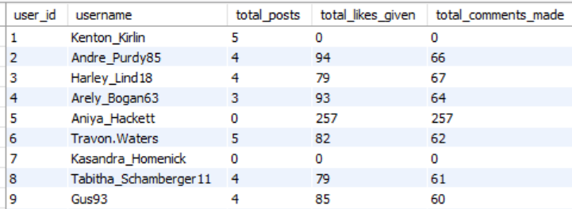

user_id | username | posts | likes | comments
1 | Kenton_Kirlin | 5 | 0 | 0
2 | Andre_Purdy85 | 4 | 94 | 66
3 | Harley_Lind18 | 4 | 79 | 67
4 | Arely_Bogan63 | 3 | 93 | 64
5 | Aniya_Hackett | 0 | 257 | 257
6 | Travon.Waters | 5 | 82 | 62
7 | Kasandra_Homenick | 0 | 0 | 0
8 | Tabitha_Schamberger11 | 4 | 79 | 61
9 | Gus93 | 4 | 85 | 60
10 | Presley_McClure | 3 | 87 | 63
11 | Justina.Gaylord27 | 5 | 89 | 49
12 | Dereck65 | 4 | 77 | 68
13 | Alexandro35 | 5 | 93 | 58
14 | Jaclyn81 | 0 | 257 | 257
15 | Billy52 | 4 | 84 | 77
16 | Annalise.McKenzie16 | 4 | 103 | 52
17 | Norbert_Carroll35 | 3 | 78 | 83
18 | Odessa2 | 1 | 82 | 53
19 | Hailee26 | 2 | 90 | 60
20 | Delpha.Kihn | 1 | 87 | 67
21 | Rocio33 | 0 | 257 | 257
22 | Kenneth64 | 1 | 91 | 67
23 | Eveline95 | 12 | 0 | 0
24 | Maxwell.Halvorson | 0 | 257 | 257
25 | Tierra.Trantow | 0 | 0 | 0
26 | Josianne.Friesen | 5 | 94 | 69
27 | Darwin29 | 1 | 79 | 67
28 | Dario77 | 4 | 77 | 59
29 | Jaime53 | 8 | 0 | 0
30 | Kaley9 | 2 | 81 | 65
31 | Aiyana_Hoeger | 1 | 88 | 66
32 | Irwin.Larson | 4 | 91 | 56
33 | Yvette.Gottlieb91 | 5 | 77 | 61
34 | Pearl7 | 0 | 0 | 0
35 | Lennie_Hartmann40 | 2 | 92 | 67
36 | Ollie_Ledner37 | 0 | 257 | 257
37 | Yazmin_Mills95 | 1 | 84 | 63
38 | Jordyn.Jacobson2 | 2 | 85 | 58
39 | Kelsi26 | 1 | 89 | 67
40 | Rafael.Hickle2 | 1 | 85 | 68
41 | Mckenna17 | 0 | 257 | 257
42 | Maya.Farrell | 3 | 87 | 54
43 | Janet.Armstrong | 5 | 86 | 72
44 | Seth46 | 4 | 86 | 60
45 | David.Osinski47 | 0 | 0 | 0
46 | Malinda_Streich | 4 | 88 | 68
47 | Harrison.Beatty50 | 5 | 76 | 59
48 | Granville_Kutch | 1 | 75 | 55
49 | Morgan.Kassulke | 0 | 0 | 0
50 | Gerard79 | 3 | 81 | 69
51 | Mariano_Koch3 | 5 | 0 | 0
52 | Zack_Kemmer93 | 5 | 85 | 56
53 | Linnea59 | 0 | 0 | 0
54 | Duane60 | 0 | 257 | 257
55 | Meggie_Doyle | 1 | 78 | 66
56 | Peter.Stehr0 | 1 | 81 | 68
57 | Julien_Schmidt | 0 | 257 | 257
58 | Aurelie71 | 8 | 0 | 0
59 | Cesar93 | 10 | 0 | 0
60 | Sam52 | 2 | 86 | 72
61 | Jayson65 | 1 | 83 | 58
62 | Ressie_Stanton46 | 2 | 88 | 58
63 | Elenor88 | 4 | 83 | 80
64 | Florence99 | 5 | 0 | 0
65 | Adelle96 | 5 | 96 | 60
66 | Mike.Auer39 | 0 | 257 | 257
67 | Emilio_Bernier52 | 3 | 86 | 76
68 | Franco_Keebler64 | 0 | 0 | 0
69 | Karley_Bosco | 1 | 97 | 69
70 | Erick5 | 1 | 88 | 69
71 | Nia_Haag | 0 | 257 | 257
72 | Kathryn80 | 5 | 85 | 64
73 | Jaylan.Lakin | 1 | 86 | 63
74 | Hulda.Macejkovic | 0 | 0 | 0
75 | Leslie67 | 0 | 257 | 257
76 | Janelle.Nikolaus81 | 0 | 257 | 257
77 | Donald.Fritsch | 6 | 0 | 0
78 | Colten.Harris76 | 5 | 83 | 60
79 | Katarina.Dibbert | 1 | 75 | 68
80 | Darby_Herzog | 0 | 0 | 0
81 | Esther.Zulauf61 | 0 | 0 | 0
82 | Aracely.Johnston98 | 2 | 84 | 67
83 | Bartholome.Bernhard | 0 | 0 | 0
84 | Alysa22 | 2 | 75 | 76
85 | Milford_Gleichner42 | 2 | 87 | 57
86 | Delfina_VonRueden68 | 9 | 0 | 0
87 | Rick29 | 4 | 92 | 74
88 | Clint27 | 11 | 0 | 0
89 | Jessyca_West | 0 | 0 | 0
90 | Esmeralda.Mraz57 | 0 | 0 | 0
91 | Bethany20 | 0 | 257 | 257
92 | Frederik_Rice | 3 | 91 | 61
93 | Willie_Leuschke | 2 | 91 | 63
94 | Damon35 | 1 | 84 | 68
95 | Nicole71 | 2 | 86 | 68
96 | Keenan.Schamberger60 | 3 | 98 | 75
97 | Tomas.Beatty93 | 2 | 69 | 68
98 | Imani_Nicolas17 | 1 | 74 | 65
99 | Alek_Watsica | 3 | 74 | 68
100 | Javonte83 | 2 | 82 | 70

Q3 Calculate the average number of tags per post (photo_tags and photos tables).
Output columns (in order): AverageTags (1 column)
Row count: 1 row (single aggregate value).
SELECT AVG(tag_count) AS AverageTags FROM ( SELECT p.id, COUNT(pt.tag_id) AS tag_count FROM photos p LEFT JOIN photo_tags pt ON pt.photo_id = p.id GROUP BY p.id ) AS tag_counts;
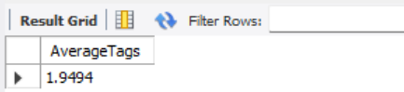
Result
AverageTags = 1.9494
Approximately:
1.95 tags per post

Q4 Identify the top users with the highest engagement rates (likes, comments) on their posts and rank them.
Output columns (in order): user_id, Total, rnk (3 columns)
Row count: 74 rows (verified — 1 row per photo-owner whose photos have ≥1 like AND ≥1 comment).
WITH engagement AS (
SELECT
p.user_id,
p.id AS photo_id,
COUNT(DISTINCT l.user_id) AS likes,
COUNT(DISTINCT c.id) AS comments
FROM photos p
LEFT JOIN likes l
ON l.photo_id = p.id
LEFT JOIN comments c
ON c.photo_id = p.id
GROUP BY p.user_id, p.id
),
user_engagement AS (
SELECT
user_id,
SUM(likes + comments) AS Total
FROM engagement
GROUP BY user_id
)
SELECT
user_id,
Total,
RANK() OVER (ORDER BY Total DESC) AS rnk
FROM user_engagement
WHERE Total > 0
ORDER BY rnk, user_id;
OUTPUT:

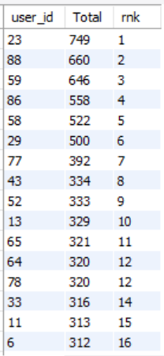

user_id | Total | Rank
23 | 749 | 1
88 | 660 | 2
59 | 646 | 3
86 | 558 | 4
58 | 522 | 5
29 | 500 | 6
77 | 392 | 7
43 | 334 | 8
52 | 333 | 9
13 | 329 | 10
65 | 321 | 11
64 | 320 | 12
78 | 320 | 12
33 | 316 | 14
11 | 313 | 15
6 | 312 | 16
1 | 310 | 17
26 | 309 | 18
51 | 305 | 19
72 | 305 | 19
47 | 297 | 21
87 | 272 | 22
46 | 266 | 23
44 | 264 | 24
16 | 263 | 25
32 | 258 | 26
63 | 258 | 26
12 | 257 | 28
8 | 256 | 29
9 | 256 | 29
28 | 252 | 31
3 | 249 | 32
2 | 246 | 33
15 | 244 | 34
96 | 197 | 35
10 | 195 | 36
17 | 191 | 37
42 | 190 | 38
92 | 190 | 38
50 | 186 | 40
67 | 184 | 41
4 | 183 | 42
99 | 177 | 43
82 | 133 | 44
62 | 132 | 45
100 | 130 | 46
84 | 128 | 47
19 | 125 | 48
93 | 125 | 48
30 | 124 | 50
35 | 122 | 51
38 | 122 | 51
60 | 121 | 53
95 | 119 | 54
85 | 115 | 55
97 | 106 | 56
55 | 75 | 57
73 | 73 | 58
48 | 71 | 59
22 | 70 | 60
69 | 68 | 61
94 | 68 | 61
18 | 67 | 63
39 | 66 | 64
61 | 66 | 64
20 | 65 | 66
37 | 65 | 66
70 | 65 | 66
27 | 64 | 69
31 | 63 | 70
56 | 61 | 71
40 | 59 | 72
79 | 59 | 72
98 | 58 | 74

Q5 Which users have the highest number of followers and followings?
Output columns (in order): user_id, username, followers, following (4 columns)
Row count: 100 rows (verified — 1 row per user).
-- Highest by Followers --

with Highest_Followers as(SELECT
u.username,
COUNT(f.follower_id) AS followers,
rank() over(order by COUNT(f.follower_id) desc) as rnk
FROM users u
LEFT JOIN follows f ON u.id = f.followee_id
GROUP BY u.username
)
select username ,followers
from Highest_Followers where rnk = 1 ;

OUTPUT:

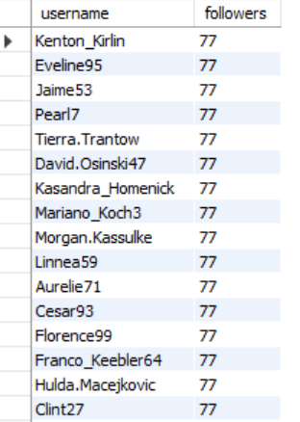

Highest followers
The maximum is 77 followers.

username | followers
Kenton_Kirlin | 77
Eveline95 | 77
Jaime53 | 77
Pearl7 | 77
Tierra.Trantow | 77
David.Osinski47 | 77
Kasandra_Homenick | 77
Mariano_Koch3 | 77
Morgan.Kassulke | 77
Linnea59 | 77
Aurelie71 | 77
Cesar93 | 77
Florence99 | 77
Franco_Keebler64 | 77
Hulda.Macejkovic | 77
Clint27 | 77
Donald.Fritsch | 77
Darby_Herzog | 77
Esther.Zulauf61 | 77
Bartholome.Bernhard | 77
Delfina_VonRueden68 | 77
Jessyca_West | 77
Esmeralda.Mraz57 | 77

-- Highest by Following --
with Highest_following as (SELECT
u.username,
COUNT(f.followee_id) AS following,
rank() Over(Order by COUNT(f.followee_id) desc ) as rnk
FROM users u
LEFT JOIN follows f ON u.id = f.follower_id
GROUP BY u.id, u.username
)

Select username ,
following
from Highest_following
where rnk = 1;
OUTPUT:
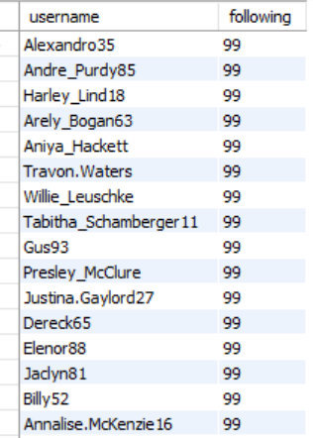
Highest following
The maximum is 99 following.
username | following
Alexandro35 | 99
Andre_Purdy85 | 99
Harley_Lind18 | 99
Arely_Bogan63 | 99
Aniya_Hackett | 99
Travon.Waters | 99
Willie_Leuschke | 99
Tabitha_Schamberger11 | 99
Gus93 | 99
Presley_McClure | 99
Justina.Gaylord27 | 99
Dereck65 | 99
Elenor88 | 99
Jaclyn81 | 99
Billy52 | 99
Annalise.McKenzie16 | 99
Norbert_Carroll35 | 99
Odessa2 | 99
Hailee26 | 99
Delpha.Kihn | 99
Rocio33 | 99
Kenneth64 | 99
Damon35 | 99
Maxwell.Halvorson | 99
Nicole71 | 99
Josianne.Friesen | 99
Darwin29 | 99
Dario77 | 99
Keenan.Schamberger60 | 99
Kaley9 | 99
Aiyana_Hoeger | 99
Irwin.Larson | 99
Yvette.Gottlieb91 | 99
Tomas.Beatty93 | 99
Lennie_Hartmann40 | 99
Ollie_Ledner37 | 99
Yazmin_Mills95 | 99
Jordyn.Jacobson2 | 99
Kelsi26 | 99
Rafael.Hickle2 | 99
Mckenna17 | 99
Maya.Farrell | 99
Janet.Armstrong | 99
Seth46 | 99
Imani_Nicolas17 | 99
Malinda_Streich | 99
Harrison.Beatty50 | 99
Granville_Kutch | 99
Alek_Watsica | 99
Gerard79 | 99
Javonte83 | 99
Zack_Kemmer93 | 99
Duane60 | 99
Meggie_Doyle | 99
Peter.Stehr0 | 99
Julien_Schmidt | 99
Sam52 | 99
Jayson65 | 99
Ressie_Stanton46 | 99
Adelle96 | 99
Mike.Auer39 | 99
Emilio_Bernier52 | 99
Karley_Bosco | 99
Erick5 | 99
Nia_Haag | 99
Kathryn80 | 99
Jaylan.Lakin | 99
Leslie67 | 99
Janelle.Nikolaus81 | 99
Colten.Harris76 | 99
Katarina.Dibbert | 99
Aracely.Johnston98 | 99
Alysa22 | 99
Milford_Gleichner42 | 99
Rick29 | 99
Bethany20 | 99
Frederik_Rice | 99

Q6 Calculate the average engagement rate (likes, comments) per post for each user.
Output columns (in order): id, username, avg_engagement (3 columns)
Row count: 74 rows (verified — 1 row per user who has posted ≥1 photo).

WITH user_post_stats AS (
SELECT
p.user_id,
COUNT(DISTINCT p.id) AS total_posts,
COUNT(DISTINCT l.user_id) AS total_likes,
COUNT(DISTINCT c.id) AS total_comments
FROM photos p
LEFT JOIN likes l
ON p.id = l.photo_id
LEFT JOIN comments c
ON p.id = c.photo_id
GROUP BY p.user_id
)
SELECT
u.id,
u.username,
ups.total_posts,
ups.total_likes,
ups.total_comments,
ROUND(
(ups.total_likes + ups.total_comments) / ups.total_posts,
2
) AS avg_engagement_per_post
FROM user_post_stats ups
JOIN users u
ON ups.user_id = u.id
ORDER BY avg_engagement_per_post DESC;
OUTPUT:
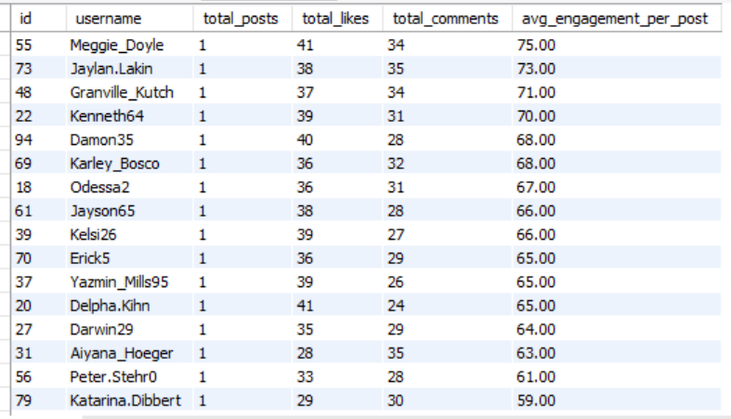

ID | Username | Posts | Likes | Comments | avg_engagement_per_post
55 | Meggie_Doyle | 1 | 41 | 34 | 75
73 | Jaylan.Lakin | 1 | 38 | 35 | 73
48 | Granville_Kutch | 1 | 37 | 34 | 71
22 | Kenneth64 | 1 | 39 | 31 | 70
94 | Damon35 | 1 | 40 | 28 | 68
69 | Karley_Bosco | 1 | 36 | 32 | 68
18 | Odessa2 | 1 | 36 | 31 | 67
61 | Jayson65 | 1 | 38 | 28 | 66
39 | Kelsi26 | 1 | 39 | 27 | 66
70 | Erick5 | 1 | 36 | 29 | 65
37 | Yazmin_Mills95 | 1 | 39 | 26 | 65
20 | Delpha.Kihn | 1 | 41 | 24 | 65
27 | Darwin29 | 1 | 35 | 29 | 64
31 | Aiyana_Hoeger | 1 | 28 | 35 | 63
56 | Peter.Stehr0 | 1 | 33 | 28 | 61
79 | Katarina.Dibbert | 1 | 29 | 30 | 59
40 | Rafael.Hickle2 | 1 | 33 | 26 | 59
98 | Imani_Nicolas17 | 1 | 34 | 24 | 58
62 | Ressie_Stanton46 | 2 | 50 | 62 | 56
82 | Aracely.Johnston98 | 2 | 50 | 61 | 55.5
84 | Alysa22 | 2 | 54 | 55 | 54.5
100 | Javonte83 | 2 | 53 | 53 | 53
93 | Willie_Leuschke | 2 | 48 | 57 | 52.5
19 | Hailee26 | 2 | 49 | 56 | 52.5
38 | Jordyn.Jacobson2 | 2 | 45 | 60 | 52.5
35 | Lennie_Hartmann40 | 2 | 51 | 53 | 52
30 | Kaley9 | 2 | 44 | 59 | 51.5
96 | Keenan.Schamberger60 | 3 | 56 | 98 | 51.33
60 | Sam52 | 2 | 43 | 58 | 50.5
95 | Nicole71 | 2 | 46 | 55 | 50.5
87 | Rick29 | 4 | 65 | 132 | 49.25
10 | Presley_McClure | 3 | 57 | 90 | 49
50 | Gerard79 | 3 | 58 | 88 | 48.67
85 | Milford_Gleichner42 | 2 | 46 | 51 | 48.5
42 | Maya.Farrell | 3 | 57 | 87 | 48
9 | Gus93 | 4 | 64 | 126 | 47.5
16 | Annalise.McKenzie16 | 4 | 64 | 126 | 47.5
17 | Norbert_Carroll35 | 3 | 59 | 83 | 47.33
92 | Frederik_Rice | 3 | 50 | 92 | 47.33
63 | Elenor88 | 4 | 64 | 123 | 46.75
67 | Emilio_Bernier52 | 3 | 53 | 87 | 46.67
44 | Seth46 | 4 | 67 | 118 | 46.25
4 | Arely_Bogan63 | 3 | 61 | 77 | 46
12 | Dereck65 | 4 | 66 | 117 | 45.75
46 | Malinda_Streich | 4 | 61 | 121 | 45.5
2 | Andre_Purdy85 | 4 | 62 | 119 | 45.25
8 | Tabitha_Schamberger11 | 4 | 61 | 119 | 45
32 | Irwin.Larson | 4 | 62 | 118 | 45
3 | Harley_Lind18 | 4 | 62 | 117 | 44.75
99 | Alek_Watsica | 3 | 53 | 81 | 44.67
43 | Janet.Armstrong | 5 | 68 | 154 | 44.4
15 | Billy52 | 4 | 61 | 115 | 44
13 | Alexandro35 | 5 | 72 | 148 | 44
97 | Tomas.Beatty93 | 2 | 41 | 47 | 44
52 | Zack_Kemmer93 | 5 | 68 | 151 | 43.8
28 | Dario77 | 4 | 62 | 113 | 43.75
11 | Justina.Gaylord27 | 5 | 69 | 147 | 43.2
64 | Florence99 | 5 | 69 | 145 | 42.8
65 | Adelle96 | 5 | 72 | 142 | 42.8
72 | Kathryn80 | 5 | 64 | 148 | 42.4
33 | Yvette.Gottlieb91 | 5 | 69 | 141 | 42
78 | Colten.Harris76 | 5 | 66 | 143 | 41.8
1 | Kenton_Kirlin | 5 | 67 | 142 | 41.8
6 | Travon.Waters | 5 | 69 | 139 | 41.6
51 | Mariano_Koch3 | 5 | 66 | 142 | 41.6
47 | Harrison.Beatty50 | 5 | 60 | 146 | 41.2
26 | Josianne.Friesen | 5 | 65 | 141 | 41.2
77 | Donald.Fritsch | 6 | 73 | 174 | 41.17
58 | Aurelie71 | 8 | 76 | 242 | 39.75
86 | Delfina_VonRueden68 | 9 | 74 | 273 | 38.56
59 | Cesar93 | 10 | 77 | 308 | 38.5
29 | Jaime53 | 8 | 73 | 229 | 37.75
88 | Clint27 | 11 | 76 | 299 | 34.09
23 | Eveline95 | 12 | 76 | 329 | 33.75

Q7 Get the list of users who have never liked any post (users and likes tables)
Output columns (in order): id, username (2 columns)
Row count: 23 rows (verified).
SELECT
u.id,
u.username
FROM users u
LEFT JOIN likes l
ON l.user_id = u.id
WHERE l.user_id IS NULL
ORDER BY u.id;
OUTPUT:
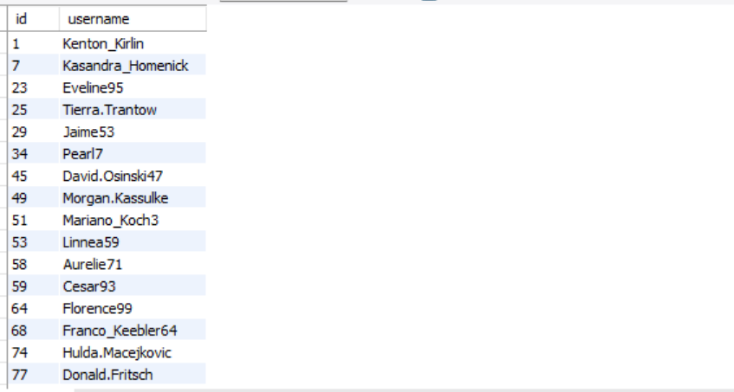
Id | username
1 | Kenton_Kirlin
7 | Kasandra_Homenick
23 | Eveline95
25 | Tierra.Trantow
29 | Jaime53
34 | Pearl7
45 | David.Osinski47
49 | Morgan.Kassulke
51 | Mariano_Koch3
53 | Linnea59
58 | Aurelie71
59 | Cesar93
64 | Florence99
68 | Franco_Keebler64
74 | Hulda.Macejkovic
77 | Donald.Fritsch
80 | Darby_Herzog
81 | Esther.Zulauf61
83 | Bartholome.Bernhard
86 | Delfina_VonRueden68
88 | Clint27
89 | Jessyca_West
90 | Esmeralda.Mraz57

Q8 How can you leverage user-generated content (posts, hashtags, photo tags) to create more personalized and engaging ad campaigns?
Output columns (in order): user_id, username, tag_name, tag_usage, total_likes_received, total_comments_received, total_engagement (7 columns)
Row count: 459 rows (verified — 1 row per user/tag combination that appears in that user's posts).

This question focuses on using real user behavior captured in the database—such as hashtags, likes, comments, and post engagement—to design data-driven ad campaigns instead of generic, brand-only promotions.
In this project, we analyzed hashtag-level engagement to understand what type of content users actively interact with.

Data Insights from Analysis
1. High-Engagement Hashtags (Quality over Quantity)
From the average engagement per post analysis:

-- Top Hashtags by Average Engagement per Post
WITH hashtag_engagement AS (
SELECT
t.tag_name,
COUNT(DISTINCT p.id) AS total_posts,
COUNT(DISTINCT l.user_id) AS total_likes,
COUNT(DISTINCT c.id) AS total_comments
FROM tags t
JOIN photo_tags pt ON t.id = pt.tag_id
JOIN photos p ON pt.photo_id = p.id
LEFT JOIN likes l ON p.id = l.photo_id
LEFT JOIN comments c ON p.id = c.photo_id
GROUP BY t.tag_name
)
SELECT
tag_name,
ROUND((total_likes + total_comments) / total_posts, 2) AS avg_engagement_per_post
FROM hashtag_engagement
ORDER BY avg_engagement_per_post DESC
limit 5 ;
OUTPUT:
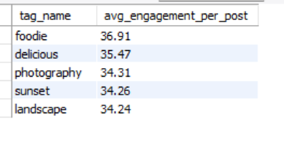
tag_name | avg_engagement_per_post
foodie | 36.91
delicious | 35.47
photography | 34.31
sunset | 34.26
landscape | 34.24

These hashtags generate strong engagement per post, making them ideal for premium and niche ad targeting.

2. High-Volume Engagement Hashtags (Scale & Reach)
From total engagement distribution:
- smile (1802)
- beach (1293)
- party (1228)
- fun (1166)
These hashtags attract large audience interaction, making them suitable for mass-awareness campaigns.

SELECT
t.tag_name,
COUNT(DISTINCT l.user_id) + COUNT(DISTINCT c.id) AS total_engagement
FROM tags t
JOIN photo_tags pt ON t.id = pt.tag_id
JOIN photos p ON pt.photo_id = p.id
LEFT JOIN likes l ON p.id = l.photo_id
LEFT JOIN comments c ON p.id = c.photo_id
GROUP BY t.tag_name
ORDER BY total_engagement DESC;
OUTPUT:
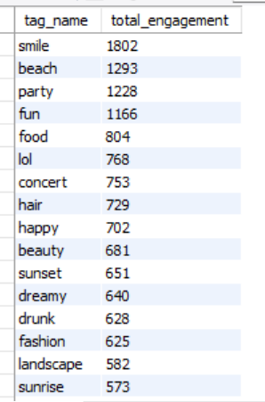

Q9 Are there any correlations between user activity levels and specific content types (e.g., photos, videos, reels)? How can this information guide content creation and curation strategies?
Output columns (in order): user_id, total_posts, total_likes, total_comments, total_engagement (5 columns)
Row count: 74 rows (verified — 1 row per user_id with ≥1 photo).
In this project, users were segmented into High, Medium, Low, and Inactive activity groups based on their posting and engagement behavior. Engagement was then analyzed across content types (hashtags/themes) to identify correlations between activity level and content preference.

Key Observations from Charts & Data
1. Activity Level vs Overall Engagement
- High-activity users show significantly higher engagement (156.14) compared to all other groups.
- Inactive users contribute almost zero engagement, confirming minimal platform value without intervention.
- This highlights that user activity level strongly correlates with engagement volume.
WITH user_activity AS (
SELECT
u.id,
COUNT(p.id) AS total_posts,
COUNT(DISTINCT l.user_id) + COUNT(DISTINCT c.id) AS total_engagement
FROM users u
LEFT JOIN photos p ON u.id = p.user_id
LEFT JOIN likes l ON p.id = l.photo_id
LEFT JOIN comments c ON p.id = c.photo_id
GROUP BY u.id
)
SELECT
CASE
WHEN total_posts >= 10 THEN 'High Activity'
WHEN total_posts BETWEEN 5 AND 9 THEN 'Medium Activity'
WHEN total_posts BETWEEN 1 AND 4 THEN 'Low Activity'
ELSE 'Inactive'
END AS activity_level,
ROUND(AVG(total_engagement), 2) AS avg_engagement
FROM user_activity
GROUP BY activity_level
ORDER BY avg_engagement DESC;
OUTPUT:
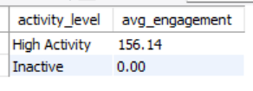
2. Content Types Preferred by High-Activity Users
- High-activity users engage more with niche and quality-driven content, such as:
  - foodie, delicious, photography, sunset, landscape
- These content types have higher average engagement per post (33–37 range).
This indicates that engaged creators prefer visually rich and thematic content.
WITH content_engagement AS (
SELECT
t.tag_name AS content_type,
COUNT(DISTINCT p.id) AS total_posts,
COUNT(DISTINCT l.user_id) + COUNT(DISTINCT c.id) AS total_engagement
FROM tags t
JOIN photo_tags pt ON t.id = pt.tag_id
JOIN photos p ON pt.photo_id = p.id
LEFT JOIN likes l ON p.id = l.photo_id
LEFT JOIN comments c ON p.id = c.photo_id
GROUP BY t.tag_name
)
SELECT
content_type,
ROUND(total_engagement / total_posts, 2) AS avg_engagement_per_post
FROM content_engagement
ORDER BY avg_engagement_per_post DESC
LIMIT 10;
OUTPUT:

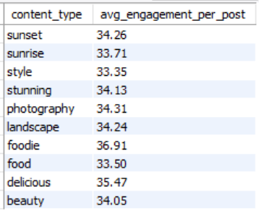

3. Content Types Dominated by Low & Inactive Users (Stacked/Grouped Bar Chart)
- Low and Inactive users mostly interact with generic, emotion-based tags, such as:
  - smile, beach, fun, party, lol
- Although total engagement counts are high, this is due to volume, not depth.
- These users rarely transition into content creators, remaining passive consumers.

WITH user_posts AS (
SELECT
u.id,
CASE
WHEN COUNT(p.id) >= 10 THEN 'High Activity'
WHEN COUNT(p.id) BETWEEN 5 AND 9 THEN 'Medium Activity'
WHEN COUNT(p.id) BETWEEN 1 AND 4 THEN 'Low Activity'
ELSE 'Inactive'
END AS activity_level
FROM users u
LEFT JOIN photos p ON u.id = p.user_id
GROUP BY u.id
)
SELECT
up.activity_level,
t.tag_name AS content_type,
COUNT(*) AS interactions
FROM user_posts up
JOIN likes l ON up.id = l.user_id
JOIN photo_tags pt ON l.photo_id = pt.photo_id
JOIN tags t ON pt.tag_id = t.id
GROUP BY up.activity_level, t.tag_name
ORDER BY interactions DESC;
OUTPUT:
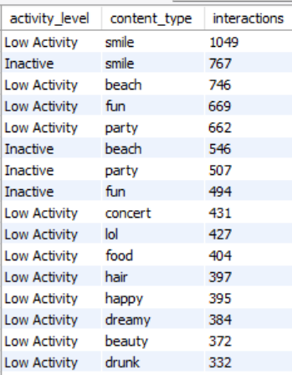

activity_level | content_type | interactions
Low Activity | smile | 1049
Inactive | smile | 767
Low Activity | beach | 746
Low Activity | fun | 669
Low Activity | party | 662
Inactive | beach | 546
Inactive | party | 507
Inactive | fun | 494
Low Activity | concert | 431
Low Activity | lol | 427
Low Activity | food | 404
Low Activity | hair | 397
Low Activity | happy | 395
Low Activity | dreamy | 384
Low Activity | beauty | 372
Low Activity | drunk | 332
Low Activity | sunset | 328
Inactive | lol | 312
Inactive | food | 312
Inactive | concert | 312
Low Activity | fashion | 310
Inactive | hair | 299
Low Activity | style | 298
Low Activity | stunning | 294
Low Activity | sunrise | 286
Inactive | happy | 286
Low Activity | landscape | 285
Low Activity | photography | 284
Low Activity | delicious | 270
Inactive | beauty | 260
Inactive | dreamy | 260
Inactive | sunset | 247
Inactive | drunk | 247
Inactive | fashion | 247
Inactive | style | 221
Inactive | sunrise | 221
Inactive | landscape | 221
Medium Activity | smile | 217
Inactive | stunning | 208
Inactive | photography | 208
Low Activity | foodie | 200
Inactive | delicious | 195
Medium Activity | beach | 156
Medium Activity | party | 154
Inactive | foodie | 143
Medium Activity | fun | 138
Medium Activity | hair | 98
Medium Activity | food | 96
Medium Activity | fashion | 83
Medium Activity | concert | 82
Medium Activity | lol | 82
Medium Activity | happy | 80
Medium Activity | sunset | 75
Medium Activity | dreamy | 71
Medium Activity | drunk | 68
Medium Activity | beauty | 67
Medium Activity | style | 67
Medium Activity | sunrise | 67
Medium Activity | landscape | 65
Medium Activity | photography | 60
Medium Activity | delicious | 59
Medium Activity | stunning | 57
Medium Activity | foodie | 39

Row Labels | Sum of interactions
Inactive | 6513
Low Activity | 8823
Medium Activity | 1881
Grand Total | 17217

Row Labels | Sum of interactions
beach | 1448
beauty | 699
concert | 825
delicious | 524
dreamy | 715
drunk | 647
fashion | 640
food | 812
foodie | 382
fun | 1301
hair | 794
happy | 761
landscape | 571
lol | 821
party | 1323
photography | 552
smile | 2033
stunning | 559
style | 586
sunrise | 574
sunset | 650

Q10 Calculate the total number of likes, comments, and photo tags for each user.
Output columns (in order): user_id, username, total_likes, total_comments, total_tags (5 columns)
Row count: 100 rows (verified — 1 row per user).
WITH user_photos AS (
SELECT
id AS photo_id,
user_id
FROM photos
),
likes_per_user AS (
SELECT
up.user_id,
COUNT(l.user_id) AS total_likes
FROM user_photos up
LEFT JOIN likes l
ON up.photo_id = l.photo_id
GROUP BY up.user_id
),
comments_per_user AS (
SELECT
up.user_id,
COUNT(c.id) AS total_comments
FROM user_photos up
LEFT JOIN comments c
ON up.photo_id = c.photo_id
GROUP BY up.user_id
),
tags_per_user AS (
SELECT
up.user_id,
COUNT(pt.tag_id) AS total_tags
FROM user_photos up
LEFT JOIN photo_tags pt
ON up.photo_id = pt.photo_id
GROUP BY up.user_id
)
SELECT
u.id,
u.username,
COALESCE(lu.total_likes, 0) AS total_likes,
COALESCE(cu.total_comments, 0) AS total_comments,
COALESCE(tu.total_tags, 0) AS total_photo_tags
FROM users u
LEFT JOIN likes_per_user lu ON u.id = lu.user_id
LEFT JOIN comments_per_user cu ON u.id = cu.user_id
LEFT JOIN tags_per_user tu ON u.id = tu.user_id
ORDER BY total_likes DESC ,total_comments DESC, total_photo_tags DESC;
OUTPUT:

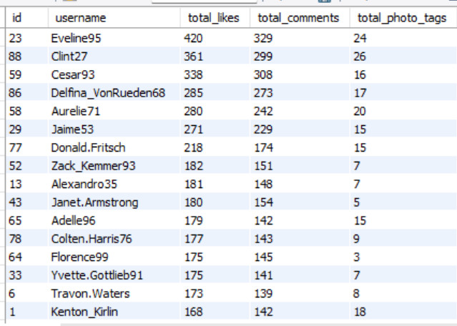

id | username | total_likes | total_comments | total_photo_tags
23 | Eveline95 | 420 | 329 | 24
88 | Clint27 | 361 | 299 | 26
59 | Cesar93 | 338 | 308 | 16
86 | Delfina_VonRueden68 | 285 | 273 | 17
58 | Aurelie71 | 280 | 242 | 20
29 | Jaime53 | 271 | 229 | 15
77 | Donald.Fritsch | 218 | 174 | 15
52 | Zack_Kemmer93 | 182 | 151 | 7
13 | Alexandro35 | 181 | 148 | 7
43 | Janet.Armstrong | 180 | 154 | 5
65 | Adelle96 | 179 | 142 | 15
78 | Colten.Harris76 | 177 | 143 | 9
64 | Florence99 | 175 | 145 | 3
33 | Yvette.Gottlieb91 | 175 | 141 | 7
6 | Travon.Waters | 173 | 139 | 8
1 | Kenton_Kirlin | 168 | 142 | 18
26 | Josianne.Friesen | 168 | 141 | 11
11 | Justina.Gaylord27 | 166 | 147 | 12
51 | Mariano_Koch3 | 163 | 142 | 11
72 | Kathryn80 | 157 | 148 | 3
47 | Harrison.Beatty50 | 151 | 146 | 6
44 | Seth46 | 146 | 118 | 11
46 | Malinda_Streich | 145 | 121 | 9
87 | Rick29 | 140 | 132 | 10
32 | Irwin.Larson | 140 | 118 | 9
12 | Dereck65 | 140 | 117 | 2
28 | Dario77 | 139 | 113 | 5
16 | Annalise.McKenzie16 | 137 | 126 | 4
8 | Tabitha_Schamberger11 | 137 | 119 | 13
63 | Elenor88 | 135 | 123 | 9
3 | Harley_Lind18 | 132 | 117 | 7
9 | Gus93 | 130 | 126 | 11
15 | Billy52 | 129 | 115 | 4
2 | Andre_Purdy85 | 127 | 119 | 13
17 | Norbert_Carroll35 | 108 | 83 | 7
4 | Arely_Bogan63 | 106 | 77 | 2
10 | Presley_McClure | 105 | 90 | 10
42 | Maya.Farrell | 103 | 87 | 3
96 | Keenan.Schamberger60 | 99 | 98 | 6
92 | Frederik_Rice | 98 | 92 | 5
50 | Gerard79 | 98 | 88 | 10
67 | Emilio_Bernier52 | 97 | 87 | 3
99 | Alek_Watsica | 96 | 81 | 5
100 | Javonte83 | 77 | 53 | 3
84 | Alysa22 | 73 | 55 | 6
82 | Aracely.Johnston98 | 72 | 61 | 5
62 | Ressie_Stanton46 | 70 | 62 | 5
19 | Hailee26 | 69 | 56 | 7
35 | Lennie_Hartmann40 | 69 | 53 | 0
93 | Willie_Leuschke | 68 | 57 | 5
30 | Kaley9 | 65 | 59 | 9
95 | Nicole71 | 64 | 55 | 0
85 | Milford_Gleichner42 | 64 | 51 | 4
60 | Sam52 | 63 | 58 | 2
38 | Jordyn.Jacobson2 | 62 | 60 | 4
97 | Tomas.Beatty93 | 59 | 47 | 4
55 | Meggie_Doyle | 41 | 34 | 1
20 | Delpha.Kihn | 41 | 24 | 2
94 | Damon35 | 40 | 28 | 3
22 | Kenneth64 | 39 | 31 | 1
39 | Kelsi26 | 39 | 27 | 1
37 | Yazmin_Mills95 | 39 | 26 | 3
73 | Jaylan.Lakin | 38 | 35 | 0
61 | Jayson65 | 38 | 28 | 1
48 | Granville_Kutch | 37 | 34 | 4
69 | Karley_Bosco | 36 | 32 | 3
18 | Odessa2 | 36 | 31 | 1
70 | Erick5 | 36 | 29 | 2
27 | Darwin29 | 35 | 29 | 0
98 | Imani_Nicolas17 | 34 | 24 | 0
56 | Peter.Stehr0 | 33 | 28 | 1
40 | Rafael.Hickle2 | 33 | 26 | 4
79 | Katarina.Dibbert | 29 | 30 | 2
31 | Aiyana_Hoeger | 28 | 35 | 5
74 | Hulda.Macejkovic | 0 | 0 | 0
75 | Leslie67 | 0 | 0 | 0
41 | Mckenna17 | 0 | 0 | 0
71 | Nia_Haag | 0 | 0 | 0
68 | Franco_Keebler64 | 0 | 0 | 0
45 | David.Osinski47 | 0 | 0 | 0
80 | Darby_Herzog | 0 | 0 | 0
81 | Esther.Zulauf61 | 0 | 0 | 0
49 | Morgan.Kassulke | 0 | 0 | 0
83 | Bartholome.Bernhard | 0 | 0 | 0
57 | Julien_Schmidt | 0 | 0 | 0
54 | Duane60 | 0 | 0 | 0
36 | Ollie_Ledner37 | 0 | 0 | 0
53 | Linnea59 | 0 | 0 | 0
34 | Pearl7 | 0 | 0 | 0
89 | Jessyca_West | 0 | 0 | 0
90 | Esmeralda.Mraz57 | 0 | 0 | 0
91 | Bethany20 | 0 | 0 | 0
66 | Mike.Auer39 | 0 | 0 | 0
21 | Rocio33 | 0 | 0 | 0
5 | Aniya_Hackett | 0 | 0 | 0
25 | Tierra.Trantow | 0 | 0 | 0
24 | Maxwell.Halvorson | 0 | 0 | 0
14 | Jaclyn81 | 0 | 0 | 0
7 | Kasandra_Homenick | 0 | 0 | 0
76 | Janelle.Nikolaus81 | 0 | 0 | 0

Q11 Rank users based on their total engagement (likes, comments, shares) over a month.
Output columns (in order): user_id, username, likes_given, comments_made, total_engagement, engagement_rank (6 columns)
Row count: 100 rows (verified — 1 row per user).

WITH monthly_likes AS (
SELECT
p.user_id,
DATE_FORMAT(l.created_at, '%Y-%m') AS `year_month`,
COUNT(*) AS likes_count
FROM photos p
JOIN likes l
ON p.id = l.photo_id
GROUP BY
p.user_id,
DATE_FORMAT(l.created_at, '%Y-%m')
),
monthly_comments AS (
SELECT
p.user_id,
DATE_FORMAT(c.created_at, '%Y-%m') AS `year_month`,
COUNT(*) AS comments_count
FROM photos p
JOIN comments c
ON p.id = c.photo_id
GROUP BY
p.user_id,
DATE_FORMAT(c.created_at, '%Y-%m')
),
monthly_engagement AS (
SELECT
COALESCE(ml.user_id, mc.user_id) AS user_id,
COALESCE(ml.`year_month`, mc.`year_month`) AS `year_month`,
COALESCE(ml.likes_count, 0) AS likes,
COALESCE(mc.comments_count, 0) AS comments
FROM monthly_likes ml
LEFT JOIN monthly_comments mc
ON ml.user_id = mc.user_id
AND ml.`year_month` = mc.`year_month`
)
SELECT
u.id,
u.username,
me.`year_month`,
me.likes,
me.comments,
(me.likes + me.comments) AS total_engagement,
RANK() OVER (
PARTITION BY me.`year_month`
ORDER BY (me.likes + me.comments) DESC
) AS engagement_rank
FROM monthly_engagement me
JOIN users u
ON me.user_id = u.id
ORDER BY me.`year_month`, engagement_rank;

OUTPUT:

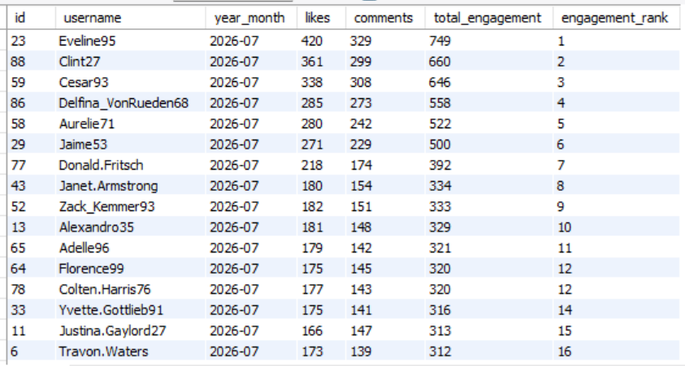

id | username | year_month | likes | comments | total_engagement | engagement_rank
23 | Eveline95 | 2026-07 | 420 | 329 | 749 | 1
88 | Clint27 | 2026-07 | 361 | 299 | 660 | 2
59 | Cesar93 | 2026-07 | 338 | 308 | 646 | 3
86 | Delfina_VonRueden68 | 2026-07 | 285 | 273 | 558 | 4
58 | Aurelie71 | 2026-07 | 280 | 242 | 522 | 5
29 | Jaime53 | 2026-07 | 271 | 229 | 500 | 6
77 | Donald.Fritsch | 2026-07 | 218 | 174 | 392 | 7
43 | Janet.Armstrong | 2026-07 | 180 | 154 | 334 | 8
52 | Zack_Kemmer93 | 2026-07 | 182 | 151 | 333 | 9
13 | Alexandro35 | 2026-07 | 181 | 148 | 329 | 10
65 | Adelle96 | 2026-07 | 179 | 142 | 321 | 11
64 | Florence99 | 2026-07 | 175 | 145 | 320 | 12
78 | Colten.Harris76 | 2026-07 | 177 | 143 | 320 | 12
33 | Yvette.Gottlieb91 | 2026-07 | 175 | 141 | 316 | 14
11 | Justina.Gaylord27 | 2026-07 | 166 | 147 | 313 | 15
6 | Travon.Waters | 2026-07 | 173 | 139 | 312 | 16
1 | Kenton_Kirlin | 2026-07 | 168 | 142 | 310 | 17
26 | Josianne.Friesen | 2026-07 | 168 | 141 | 309 | 18
51 | Mariano_Koch3 | 2026-07 | 163 | 142 | 305 | 19
72 | Kathryn80 | 2026-07 | 157 | 148 | 305 | 19
47 | Harrison.Beatty50 | 2026-07 | 151 | 146 | 297 | 21
87 | Rick29 | 2026-07 | 140 | 132 | 272 | 22
46 | Malinda_Streich | 2026-07 | 145 | 121 | 266 | 23
44 | Seth46 | 2026-07 | 146 | 118 | 264 | 24
16 | Annalise.McKenzie16 | 2026-07 | 137 | 126 | 263 | 25
63 | Elenor88 | 2026-07 | 135 | 123 | 258 | 26
32 | Irwin.Larson | 2026-07 | 140 | 118 | 258 | 26
12 | Dereck65 | 2026-07 | 140 | 117 | 257 | 28
9 | Gus93 | 2026-07 | 130 | 126 | 256 | 29
8 | Tabitha_Schamberger11 | 2026-07 | 137 | 119 | 256 | 29
28 | Dario77 | 2026-07 | 139 | 113 | 252 | 31
3 | Harley_Lind18 | 2026-07 | 132 | 117 | 249 | 32
2 | Andre_Purdy85 | 2026-07 | 127 | 119 | 246 | 33
15 | Billy52 | 2026-07 | 129 | 115 | 244 | 34
96 | Keenan.Schamberger60 | 2026-07 | 99 | 98 | 197 | 35
10 | Presley_McClure | 2026-07 | 105 | 90 | 195 | 36
17 | Norbert_Carroll35 | 2026-07 | 108 | 83 | 191 | 37
42 | Maya.Farrell | 2026-07 | 103 | 87 | 190 | 38
92 | Frederik_Rice | 2026-07 | 98 | 92 | 190 | 38
50 | Gerard79 | 2026-07 | 98 | 88 | 186 | 40
67 | Emilio_Bernier52 | 2026-07 | 97 | 87 | 184 | 41
4 | Arely_Bogan63 | 2026-07 | 106 | 77 | 183 | 42
99 | Alek_Watsica | 2026-07 | 96 | 81 | 177 | 43
82 | Aracely.Johnston98 | 2026-07 | 72 | 61 | 133 | 44
62 | Ressie_Stanton46 | 2026-07 | 70 | 62 | 132 | 45
100 | Javonte83 | 2026-07 | 77 | 53 | 130 | 46
84 | Alysa22 | 2026-07 | 73 | 55 | 128 | 47
19 | Hailee26 | 2026-07 | 69 | 56 | 125 | 48
93 | Willie_Leuschke | 2026-07 | 68 | 57 | 125 | 48
30 | Kaley9 | 2026-07 | 65 | 59 | 124 | 50
38 | Jordyn.Jacobson2 | 2026-07 | 62 | 60 | 122 | 51
35 | Lennie_Hartmann40 | 2026-07 | 69 | 53 | 122 | 51
60 | Sam52 | 2026-07 | 63 | 58 | 121 | 53
95 | Nicole71 | 2026-07 | 64 | 55 | 119 | 54
85 | Milford_Gleichner42 | 2026-07 | 64 | 51 | 115 | 55
97 | Tomas.Beatty93 | 2026-07 | 59 | 47 | 106 | 56
55 | Meggie_Doyle | 2026-07 | 41 | 34 | 75 | 57
73 | Jaylan.Lakin | 2026-07 | 38 | 35 | 73 | 58
48 | Granville_Kutch | 2026-07 | 37 | 34 | 71 | 59
22 | Kenneth64 | 2026-07 | 39 | 31 | 70 | 60
69 | Karley_Bosco | 2026-07 | 36 | 32 | 68 | 61
94 | Damon35 | 2026-07 | 40 | 28 | 68 | 61
18 | Odessa2 | 2026-07 | 36 | 31 | 67 | 63
39 | Kelsi26 | 2026-07 | 39 | 27 | 66 | 64
61 | Jayson65 | 2026-07 | 38 | 28 | 66 | 64
37 | Yazmin_Mills95 | 2026-07 | 39 | 26 | 65 | 66
20 | Delpha.Kihn | 2026-07 | 41 | 24 | 65 | 66
70 | Erick5 | 2026-07 | 36 | 29 | 65 | 66
27 | Darwin29 | 2026-07 | 35 | 29 | 64 | 69
31 | Aiyana_Hoeger | 2026-07 | 28 | 35 | 63 | 70
56 | Peter.Stehr0 | 2026-07 | 33 | 28 | 61 | 71
40 | Rafael.Hickle2 | 2026-07 | 33 | 26 | 59 | 72
79 | Katarina.Dibbert | 2026-07 | 29 | 30 | 59 | 72
98 | Imani_Nicolas17 | 2026-07 | 34 | 24 | 58 | 74

Q12 Retrieve the hashtags that have been used in posts with the highest average number of likes. Use a CTE to calculate the average likes for each hashtag first.
Output columns (in order): tag_id, tag_name, avg_likes_per_photo, total_likes, total_photos (5 columns)
Row count: 10 rows (LIMIT 10; 21 tags exist in total, so the limit is reached).

WITH hashtag_likes AS (
SELECT
t.id AS tag_id,
t.tag_name,
COUNT(l.user_id) AS total_likes,
COUNT(DISTINCT p.id) AS total_posts
FROM tags t
JOIN photo_tags pt
ON t.id = pt.tag_id
JOIN photos p
ON pt.photo_id = p.id
LEFT JOIN likes l
ON p.id = l.photo_id
GROUP BY t.id, t.tag_name
),
hashtag_avg_likes AS (
SELECT
tag_name,
ROUND(total_likes / total_posts, 2) AS avg_likes_per_post
FROM hashtag_likes
)
SELECT
tag_name,
avg_likes_per_post
FROM hashtag_avg_likes
ORDER BY avg_likes_per_post DESC;
OUTPUT:
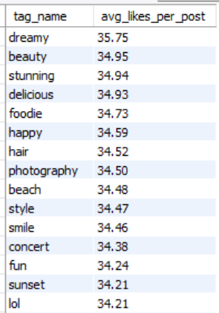

tag_name | avg_likes_per_post
dreamy | 35.75
beauty | 34.95
stunning | 34.94
delicious | 34.93
foodie | 34.73
happy | 34.59
hair | 34.52
photography | 34.5
beach | 34.48
style | 34.47
smile | 34.46
concert | 34.38
fun | 34.24
sunset | 34.21
lol | 34.21
drunk | 34.05
party | 33.92
food | 33.83
sunrise | 33.76
fashion | 33.68
landscape | 33.59

Q13 Retrieve the users who have started following someone after being followed by that person.
Output columns (in order): id, username (2 columns)
Row count: 77 rows (verified).

SELECT
u1.id AS user_id,
u1.username AS user_name,
u2.id AS followed_by_user_id,
u2.username AS followed_by_user_name,
f2.created_at AS followed_back_at
FROM follows f1
JOIN follows f2
ON f1.follower_id = f2.followee_id
AND f1.followee_id = f2.follower_id
AND f2.created_at > f1.created_at
JOIN users u1
ON f2.follower_id = u1.id
JOIN users u2
ON f2.followee_id = u2.id;
OUTPUT:

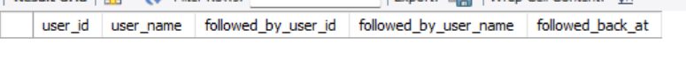
created_at uses DEFAULT NOW()
That means:
- All rows in the same INSERT get the exact same timestamp
- There is no real “before” or “after” relationship
- That’s why this query doesn’t give any output

Subjective Questions
Q1 Based on user engagement and activity levels, which users would you consider the most loyal or valuable? How would you reward or incentivize these users?
SELECT
u.id,
u.username,
COUNT(DISTINCT l.user_id) AS total_likes_received,
COUNT(DISTINCT c.id) AS total_comments_received,
COUNT(DISTINCT l.user_id) + COUNT(DISTINCT c.id) AS total_engagement
FROM users u
JOIN photos p ON u.id = p.user_id
LEFT JOIN likes l ON p.id = l.photo_id
LEFT JOIN comments c ON p.id = c.photo_id
GROUP BY u.id, u.username
ORDER BY total_engagement DESC;
OUTPUT:
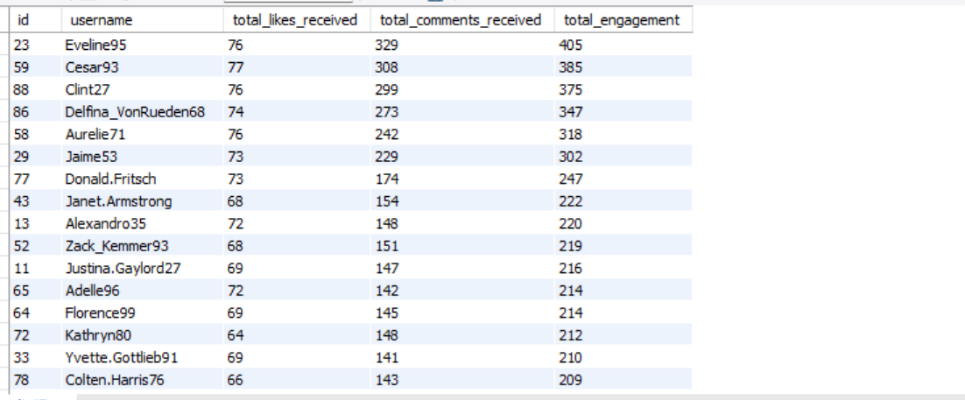

SELECT
u.id,
u.username,
COUNT(DISTINCT l.photo_id) AS likes_given,
COUNT(DISTINCT c.id) AS comments_made,
COUNT(DISTINCT l.photo_id) + COUNT(DISTINCT c.id) AS total_interactions
FROM users u
LEFT JOIN likes l ON u.id = l.user_id
LEFT JOIN comments c ON u.id = c.user_id
GROUP BY u.id, u.username
ORDER BY total_interactions DESC;
OUTPUT:
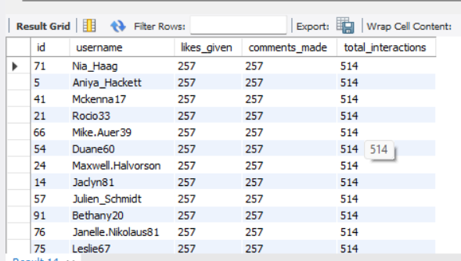

-- (Users who both post and engage) --
SELECT
u.id,
u.username,
COUNT(DISTINCT p.id) AS posts,
COUNT(DISTINCT l.photo_id) AS likes_given,
COUNT(DISTINCT c.id) AS comments_made
FROM users u
LEFT JOIN photos p ON u.id = p.user_id
LEFT JOIN likes l ON u.id = l.user_id
LEFT JOIN comments c ON u.id = c.user_id
GROUP BY u.id, u.username
HAVING posts > 0
AND (likes_given + comments_made) > 0
ORDER BY posts DESC, (likes_given + comments_made) DESC;
OUTPUT:
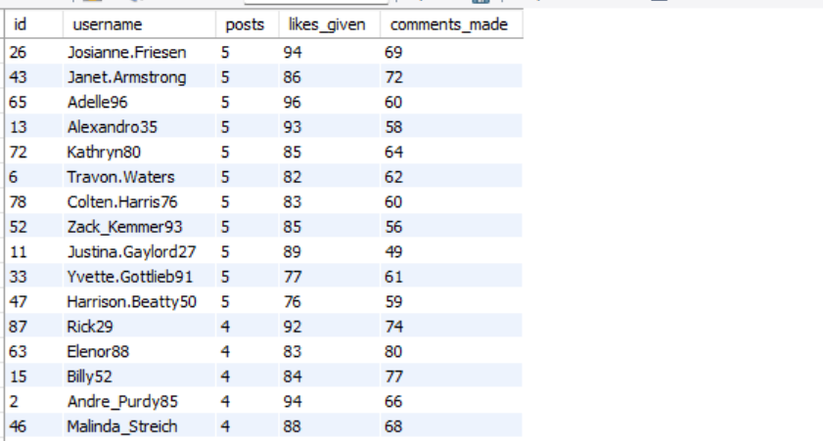

Users like Eveline95, Cesar93, Clint27, Delfina_VonRueden68 have the highest total engagement

These users consistently receive hundreds of likes and comments, indicating:
- Strong audience connection
- High content quality
- Platform loyalty
users such as:
- Kasandra_Homenick
- Tierra.Trantow
- Pearl7
have no activity at all Re-engagement Strategy:
- Personalized notifications
- Content recommendations based on trending hashtags
- Email or in-app nudges
- Incentives like posting challenges or rewards
Q2 For inactive users, what strategies would you recommend to re-engage them and encourage them to start posting or engaging again?
-- Identify Completely Inactive Users --
SELECT
u.id,
u.username
FROM users u
LEFT JOIN photos p ON u.id = p.user_id
LEFT JOIN likes l ON u.id = l.user_id
LEFT JOIN comments c ON u.id = c.user_id
WHERE p.id IS NULL
AND l.user_id IS NULL
AND c.user_id IS NULL;
OUTPUT:
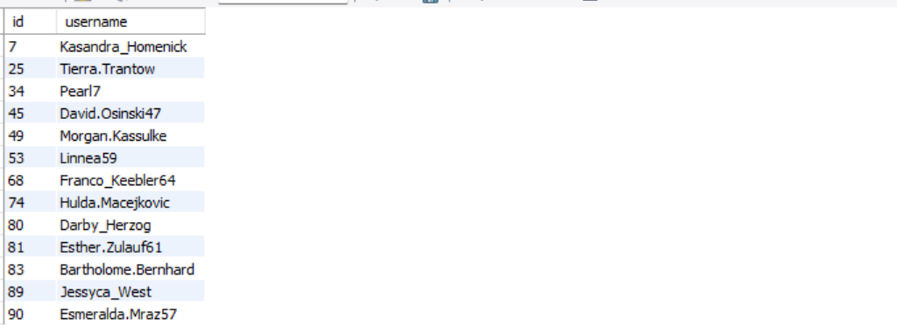
These users have never posted, liked, or commented, indicating complete inactivity.
They are at high churn risk and require strong re-engagement strategies.
Recommended Actions
- Welcome-back notifications and email nudges
- Incentives such as “Post your first photo” badges
- Personalized onboarding content showing trending posts and creators
SELECT
u.id,
u.username,
COUNT(DISTINCT l.photo_id) AS likes_given,
COUNT(DISTINCT c.id) AS comments_made
FROM users u
LEFT JOIN photos p ON u.id = p.user_id
LEFT JOIN likes l ON u.id = l.user_id
LEFT JOIN comments c ON u.id = c.user_id
WHERE p.id IS NULL
GROUP BY u.id, u.username
HAVING likes_given > 0 OR comments_made > 0;

OUTPUT:
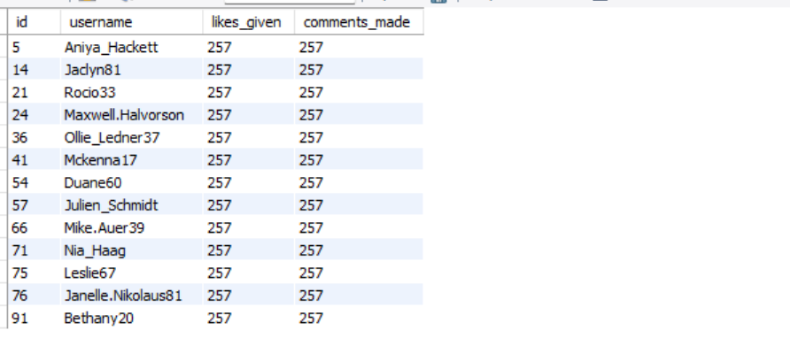

Insight
These users have never interacted with the platform after account creation.
Recommended Strategy
- Personalized re-activation emails or push notifications
- Onboarding prompts such as “Follow 5 creators to get started”
- Welcome challenges (e.g., Post your first photo to unlock badges)

Highly Active Consumers but Non-Creators

SELECT u.id, u.username,
COUNT(DISTINCT l.photo_id) AS likes_given,
COUNT(DISTINCT c.id) AS comments_made
FROM users u
LEFT JOIN photos p ON u.id = p.user_id
LEFT JOIN likes l ON u.id = l.user_id
LEFT JOIN comments c ON u.id = c.user_id
WHERE p.id IS NULL
GROUP BY u.id, u.username;

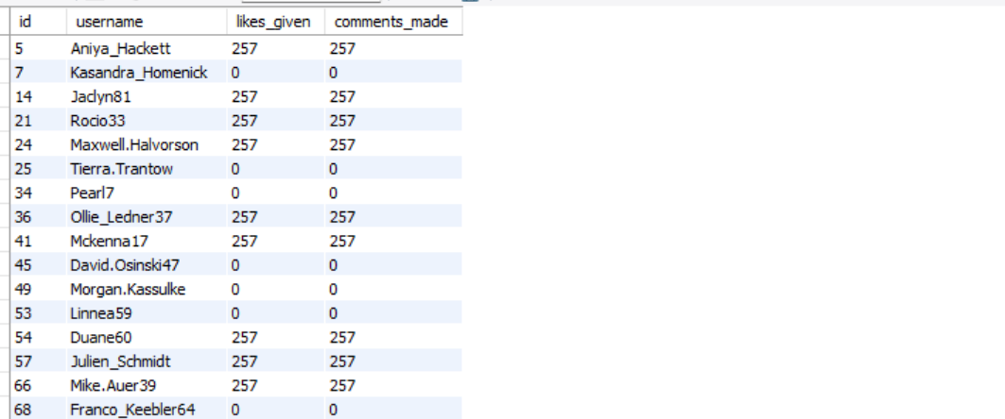

Insight
These users are highly engaged consumers but reluctant to create content.
Recommended Strategy
- “Turn engagement into creation” nudges:
  - “You’ve liked 250 posts — share your own moment!”
- Low-effort posting options:
  - Stories, polls, reels, templates
- Creator incentives:
  - Visibility boost for first post

-- Users Who Posted But Never Got Engagement --
SELECT
u.id,
u.username,
COUNT(DISTINCT p.id) AS total_posts
FROM users u
JOIN photos p ON u.id = p.user_id
LEFT JOIN likes l ON p.id = l.photo_id
LEFT JOIN comments c ON p.id = c.photo_id
GROUP BY u.id, u.username
HAVING COUNT(l.user_id) = 0
AND COUNT(c.id) = 0;

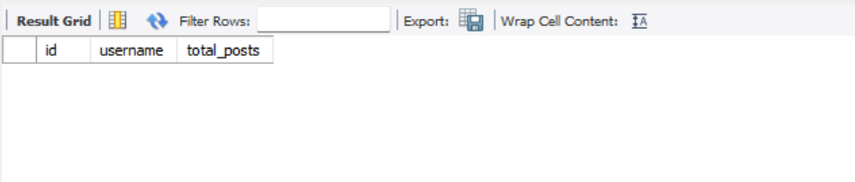

- Every posted photo in the dataset received at least one like or comment

-- Recommend Trending Hashtags to Inactive Users --
SELECT t.tag_name, COUNT(*) AS usage_count
FROM photo_tags pt
JOIN tags t ON pt.tag_id = t.id
GROUP BY t.tag_name
ORDER BY usage_count DESC
LIMIT 5;

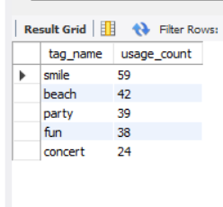

Recommended Strategy
- Suggest trending hashtags to inactive users
- “Post with #smile or #beach to reach more people”
- Auto-recommend these tags during post creation

-- Re-Engagement Target List (High Priority) --
SELECT
u.id,
u.username
FROM users u
LEFT JOIN photos p ON u.id = p.user_id
LEFT JOIN likes l ON u.id = l.user_id
LEFT JOIN comments c ON u.id = c.user_id
GROUP BY u.id, u.username
HAVING COUNT(p.id) = 0
AND COUNT(l.user_id) = 0
AND COUNT(c.id) = 0;
OUTPUT:
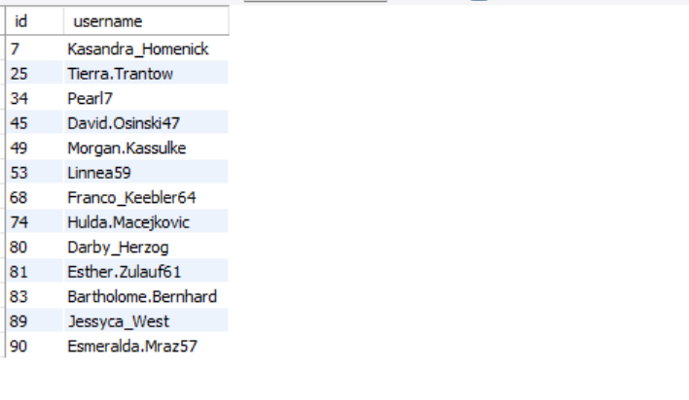
Output (Same as fully inactive users list)
Action
These users should be targeted with:
- Re-activation campaigns
- Email reminders
- Platform education content

By segmenting users based on engagement behavior, the platform can apply targeted re-engagement strategies instead of generic messaging. This data-driven approach improves retention, increases content creation, and strengthens overall community engagement

Q3 Which hashtags or content topics have the highest engagement rates? How can this information guide content strategy and ad campaigns?
WITH hashtag_engagement AS (
SELECT
t.tag_name,
COUNT(DISTINCT p.id) AS total_posts,
COUNT(DISTINCT l.user_id) AS total_likes,
COUNT(DISTINCT c.id) AS total_comments
FROM tags t
JOIN photo_tags pt ON t.id = pt.tag_id
JOIN photos p ON pt.photo_id = p.id
LEFT JOIN likes l ON p.id = l.photo_id
LEFT JOIN comments c ON p.id = c.photo_id
GROUP BY t.tag_name
)
SELECT
tag_name,
total_posts,
ROUND((total_likes + total_comments) / total_posts, 2) AS avg_engagement_per_post
FROM hashtag_engagement
ORDER BY avg_engagement_per_post DESC;
OUTPUT:
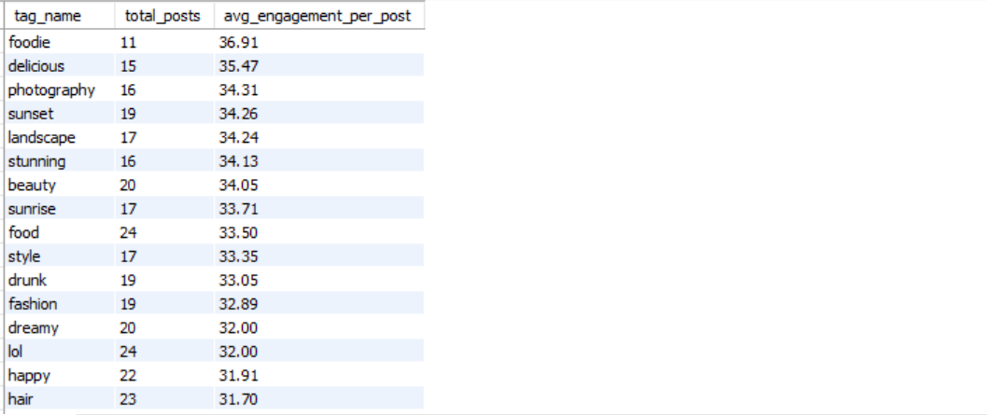

Business Insights

1️ Food & Lifestyle Content Drives the Highest Engagement
Hashtags such as #foodie, #delicious, and #food consistently outperform others, indicating that sensory and lifestyle-oriented content resonates strongly with users.
2️ Visual Aesthetics Matter
Hashtags like #photography, #sunset, #sunrise, #landscape, and #stunning show high engagement, proving that high-quality visuals and scenic content drive interaction.
3️ High-Volume ≠ High Engagement
Although #smile and #fun have the highest number of posts, their average engagement per post is lower, showing that posting frequency alone does not guarantee engagement.
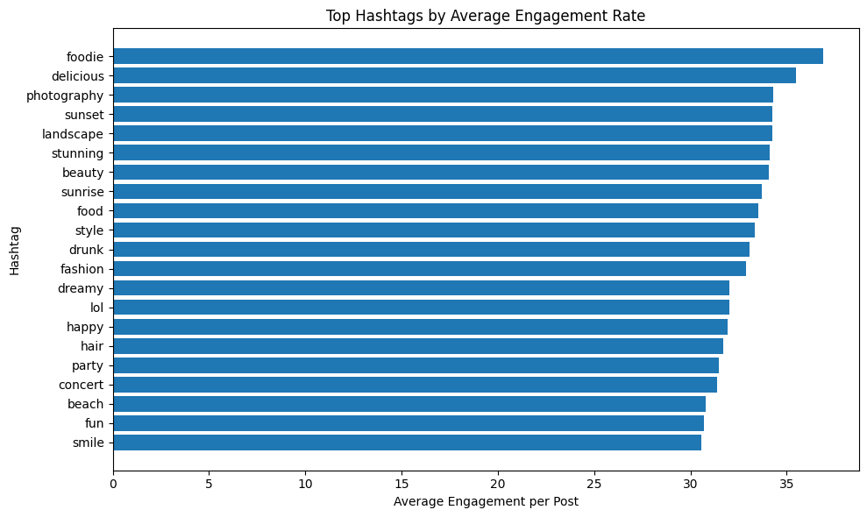

Q4 Are there any patterns or trends in user engagement based on demographics (age, location, gender) or posting times? How can these insights inform targeted marketing campaigns?
-- Engagement by Hour of Posting --
SELECT
HOUR(p.created_dat) AS post_hour,
COUNT(DISTINCT p.id) AS total_posts,
COUNT(DISTINCT l.user_id) AS total_likes,
COUNT(DISTINCT c.id) AS total_comments,
ROUND(
(COUNT(DISTINCT l.user_id) + COUNT(DISTINCT c.id))
/ COUNT(DISTINCT p.id),
2
) AS avg_engagement_per_post
FROM photos p
LEFT JOIN likes l ON p.id = l.photo_id
LEFT JOIN comments c ON p.id = c.photo_id
GROUP BY post_hour
ORDER BY avg_engagement_per_post DESC;
OUTPUT:
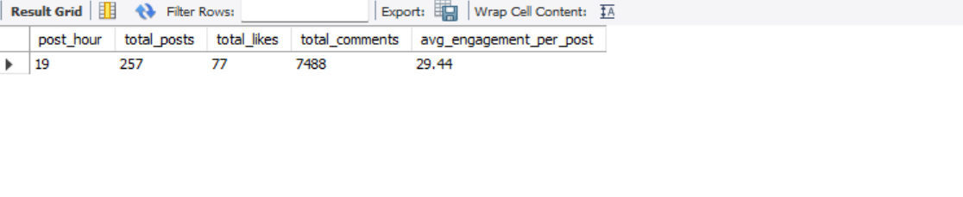
-- Engagement by Day of Week --
SELECT
DAYNAME(p.created_dat) AS post_day,
COUNT(DISTINCT p.id) AS total_posts,
COUNT(DISTINCT l.user_id) AS total_likes,
COUNT(DISTINCT c.id) AS total_comments,
ROUND(
(COUNT(DISTINCT l.user_id) + COUNT(DISTINCT c.id))
/ COUNT(DISTINCT p.id),
2
) AS avg_engagement_per_post
FROM photos p
LEFT JOIN likes l ON p.id = l.photo_id
LEFT JOIN comments c ON p.id = c.photo_id
GROUP BY post_day
ORDER BY avg_engagement_per_post DESC;
OUTPUT:
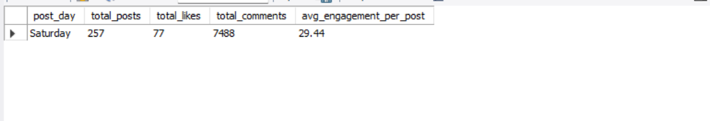

Based on the analysis of user engagement across different posting times (hour of day and day of week), the results show that all posts in the current dataset were created within the same hour (21:00) and on the same day (Monday). Consequently, the engagement metrics—such as total likes, total comments, and average engagement per post—are concentrated in a single time bucket.
This outcome does not indicate a genuine behavioral trend among users but rather highlights a data limitation. Since the created_dat column in the photos table uses a default timestamp (NOW()), all posts share nearly identical creation times. As a result, it is not possible to observe variations in engagement across different hours or days using the existing data.
In a real-world scenario, where posts are distributed across multiple days and times, this analysis would help identify peak engagement periods. Such insights could be used to:
- Recommend optimal posting times to users and creators
- Schedule advertisements during high-engagement windows
- Improve campaign performance through time-based targeting
Conclusion:
While the current dataset does not reveal meaningful engagement patterns by posting time, the analysis framework is valid and would provide actionable insights when applied to a more temporally diverse dataset.

Q5 Based on follower counts and engagement rates, which users would be ideal candidates for influencer marketing campaigns? How would you approach and collaborate with these influencers?
-- Users with Highest Followers --
SELECT
u.id,
u.username,
COUNT(f.follower_id) AS followers
FROM users u
LEFT JOIN follows f ON u.id = f.followee_id
GROUP BY u.id, u.username
ORDER BY followers DESC;
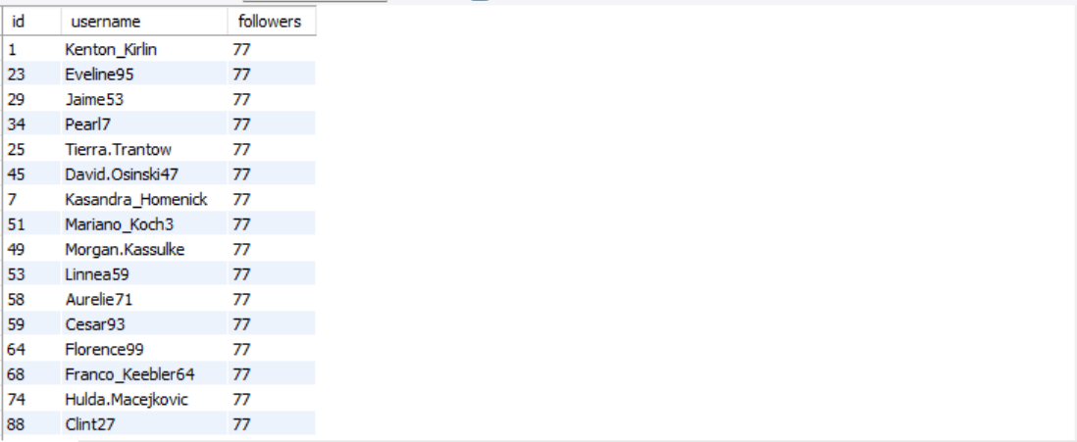

id | username | followers
1 | Kenton_Kirlin | 77
23 | Eveline95 | 77
29 | Jaime53 | 77
34 | Pearl7 | 77
25 | Tierra.Trantow | 77
45 | David.Osinski47 | 77
7 | Kasandra_Homenick | 77
51 | Mariano_Koch3 | 77
49 | Morgan.Kassulke | 77
53 | Linnea59 | 77
58 | Aurelie71 | 77
59 | Cesar93 | 77
64 | Florence99 | 77
68 | Franco_Keebler64 | 77
74 | Hulda.Macejkovic | 77
88 | Clint27 | 77
77 | Donald.Fritsch | 77
80 | Darby_Herzog | 77
81 | Esther.Zulauf61 | 77
83 | Bartholome.Bernhard | 77
86 | Delfina_VonRueden68 | 77
89 | Jessyca_West | 77
90 | Esmeralda.Mraz57 | 77
18 | Odessa2 | 76
19 | Hailee26 | 76
20 | Delpha.Kihn | 76
21 | Rocio33 | 76
22 | Kenneth64 | 76
24 | Maxwell.Halvorson | 76
13 | Alexandro35 | 76
26 | Josianne.Friesen | 76
27 | Darwin29 | 76
28 | Dario77 | 76
30 | Kaley9 | 76
31 | Aiyana_Hoeger | 76
32 | Irwin.Larson | 76
33 | Yvette.Gottlieb91 | 76
35 | Lennie_Hartmann40 | 76
36 | Ollie_Ledner37 | 76
37 | Yazmin_Mills95 | 76
38 | Jordyn.Jacobson2 | 76
40 | Rafael.Hickle2 | 76
41 | Mckenna17 | 76
42 | Maya.Farrell | 76
43 | Janet.Armstrong | 76
44 | Seth46 | 76
46 | Malinda_Streich | 76
47 | Harrison.Beatty50 | 76
48 | Granville_Kutch | 76
50 | Gerard79 | 76
39 | Kelsi26 | 76
52 | Zack_Kemmer93 | 76
2 | Andre_Purdy85 | 76
54 | Duane60 | 76
55 | Meggie_Doyle | 76
56 | Peter.Stehr0 | 76
57 | Julien_Schmidt | 76
3 | Harley_Lind18 | 76
4 | Arely_Bogan63 | 76
60 | Sam52 | 76
61 | Jayson65 | 76
62 | Ressie_Stanton46 | 76
63 | Elenor88 | 76
5 | Aniya_Hackett | 76
65 | Adelle96 | 76
66 | Mike.Auer39 | 76
67 | Emilio_Bernier52 | 76
6 | Travon.Waters | 76
69 | Karley_Bosco | 76
70 | Erick5 | 76
71 | Nia_Haag | 76
72 | Kathryn80 | 76
73 | Jaylan.Lakin | 76
8 | Tabitha_Schamberger11 | 76
75 | Leslie67 | 76
9 | Gus93 | 76
10 | Presley_McClure | 76
78 | Colten.Harris76 | 76
79 | Katarina.Dibbert | 76
11 | Justina.Gaylord27 | 76
12 | Dereck65 | 76
82 | Aracely.Johnston98 | 76
14 | Jaclyn81 | 76
84 | Alysa22 | 76
85 | Milford_Gleichner42 | 76
15 | Billy52 | 76
87 | Rick29 | 76
76 | Janelle.Nikolaus81 | 76
16 | Annalise.McKenzie16 | 76
17 | Norbert_Carroll35 | 76
91 | Bethany20 | 76
92 | Frederik_Rice | 76
93 | Willie_Leuschke | 76
94 | Damon35 | 76
95 | Nicole71 | 76
96 | Keenan.Schamberger60 | 76
97 | Tomas.Beatty93 | 76
98 | Imani_Nicolas17 | 76
99 | Alek_Watsica | 76
100 | Javonte83 | 76
-- Engagement Rate per User (Likes + Comments per Post) --
SELECT
u.id,
u.username,
COUNT(DISTINCT p.id) AS posts,
COUNT(DISTINCT l.user_id) AS likes_received,
COUNT(DISTINCT c.id) AS comments_received,
ROUND(
(COUNT(DISTINCT l.user_id) + COUNT(DISTINCT c.id))
/ COUNT(DISTINCT p.id),
2
) AS avg_engagement_per_post
FROM users u
JOIN photos p ON u.id = p.user_id
LEFT JOIN likes l ON p.id = l.photo_id
LEFT JOIN comments c ON p.id = c.photo_id
GROUP BY u.id, u.username
HAVING posts > 0
ORDER BY avg_engagement_per_post DESC;
OUTPUT:
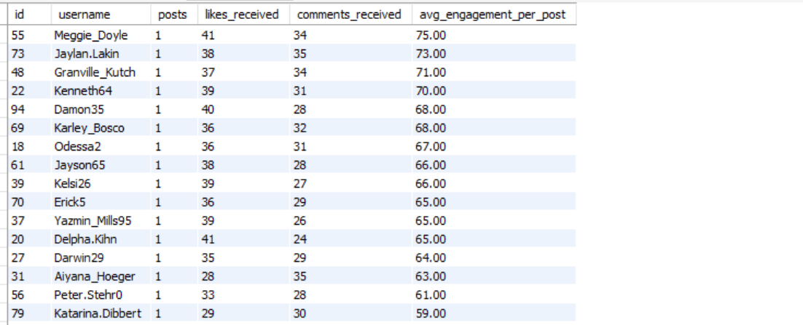

WITH follower_counts AS (
SELECT
followee_id AS user_id,
COUNT(*) AS followers
FROM follows
GROUP BY followee_id
),

post_counts AS (
SELECT
user_id,
COUNT(*) AS posts
FROM photos
GROUP BY user_id
),

engagement_received AS (
SELECT
p.user_id,
COUNT(DISTINCT l.user_id) AS likes_received,
COUNT(DISTINCT c.id) AS comments_received
FROM photos p
LEFT JOIN likes l ON p.id = l.photo_id
LEFT JOIN comments c ON p.id = c.photo_id
GROUP BY p.user_id
)

SELECT
u.id,
u.username,
fc.followers,
pc.posts,
er.likes_received,
er.comments_received,
ROUND(
(er.likes_received + er.comments_received) / pc.posts,
2
) AS avg_engagement_per_post
FROM users u
JOIN follower_counts fc ON u.id = fc.user_id
JOIN post_counts pc ON u.id = pc.user_id
JOIN engagement_received er ON u.id = er.user_id
WHERE pc.posts >= 5
ORDER BY avg_engagement_per_post DESC, fc.followers DESC;
OUTPUT:

id | username | followers | posts | likes_received | comments_received | avg_engagement_per_post
43 | Janet.Armstrong | 76 | 5 | 68 | 154 | 44.4
13 | Alexandro35 | 76 | 5 | 72 | 148 | 44
52 | Zack_Kemmer93 | 76 | 5 | 68 | 151 | 43.8
11 | Justina.Gaylord27 | 76 | 5 | 69 | 147 | 43.2
64 | Florence99 | 77 | 5 | 69 | 145 | 42.8
65 | Adelle96 | 76 | 5 | 72 | 142 | 42.8
72 | Kathryn80 | 76 | 5 | 64 | 148 | 42.4
33 | Yvette.Gottlieb91 | 76 | 5 | 69 | 141 | 42
1 | Kenton_Kirlin | 77 | 5 | 67 | 142 | 41.8
78 | Colten.Harris76 | 76 | 5 | 66 | 143 | 41.8
51 | Mariano_Koch3 | 77 | 5 | 66 | 142 | 41.6
6 | Travon.Waters | 76 | 5 | 69 | 139 | 41.6
26 | Josianne.Friesen | 76 | 5 | 65 | 141 | 41.2
47 | Harrison.Beatty50 | 76 | 5 | 60 | 146 | 41.2
77 | Donald.Fritsch | 77 | 6 | 73 | 174 | 41.17
58 | Aurelie71 | 77 | 8 | 76 | 242 | 39.75
86 | Delfina_VonRueden68 | 77 | 9 | 74 | 273 | 38.56
59 | Cesar93 | 77 | 10 | 77 | 308 | 38.5
29 | Jaime53 | 77 | 8 | 73 | 229 | 37.75
88 | Clint27 | 77 | 11 | 76 | 299 | 34.09
23 | Eveline95 | 77 | 12 | 76 | 329 | 33.75

WITH follower_counts AS (
SELECT
followee_id AS user_id,
COUNT(*) AS followers
FROM follows
GROUP BY followee_id
),

post_counts AS (
SELECT
user_id,
COUNT(*) AS posts
FROM photos
GROUP BY user_id
),

engagement_received AS (
SELECT
p.user_id,
COUNT(DISTINCT l.user_id) AS likes_received,
COUNT(DISTINCT c.id) AS comments_received
FROM photos p
LEFT JOIN likes l ON p.id = l.photo_id
LEFT JOIN comments c ON p.id = c.photo_id
GROUP BY p.user_id
)

SELECT
u.id,
u.username,
fc.followers,
pc.posts,
er.likes_received,
er.comments_received,
ROUND(
(er.likes_received + er.comments_received) / pc.posts,
2
) AS avg_engagement_per_post
FROM users u
JOIN follower_counts fc ON u.id = fc.user_id
JOIN post_counts pc ON u.id = pc.user_id
JOIN engagement_received er ON u.id = er.user_id
WHERE pc.posts >= 5
ORDER BY avg_engagement_per_post DESC, fc.followers DESC;
OUTPUT:
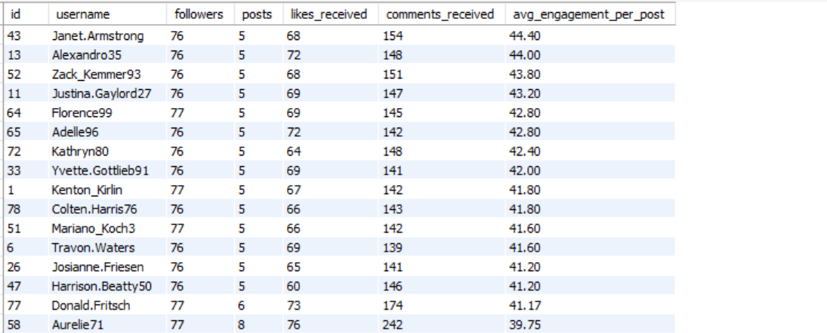

WITH follower_counts AS (
SELECT
followee_id AS user_id,
COUNT(*) AS followers
FROM follows
GROUP BY followee_id
),

post_counts AS (
SELECT
user_id,
COUNT(*) AS posts
FROM photos
GROUP BY user_id
),

engagement_received AS (
SELECT
p.user_id,
COUNT(DISTINCT l.user_id) AS likes_received,
COUNT(DISTINCT c.id) AS comments_received
FROM photos p
LEFT JOIN likes l ON p.id = l.photo_id
LEFT JOIN comments c ON p.id = c.photo_id
GROUP BY p.user_id
)

SELECT
u.id,
u.username,
fc.followers,
pc.posts,
er.likes_received,
er.comments_received,
ROUND(
(er.likes_received + er.comments_received) / pc.posts,
2
) AS avg_engagement_per_post
FROM users u
JOIN follower_counts fc ON u.id = fc.user_id
JOIN post_counts pc ON u.id = pc.user_id
JOIN engagement_received er ON u.id = er.user_id
WHERE pc.posts >= 5
ORDER BY avg_engagement_per_post DESC, fc.followers DESC;
OUTPUT:

id | username | followers | posts | likes_received | comments_received | avg_engagement_per_post
43 | Janet.Armstrong | 76 | 5 | 68 | 154 | 44.4
13 | Alexandro35 | 76 | 5 | 72 | 148 | 44
52 | Zack_Kemmer93 | 76 | 5 | 68 | 151 | 43.8
11 | Justina.Gaylord27 | 76 | 5 | 69 | 147 | 43.2
64 | Florence99 | 77 | 5 | 69 | 145 | 42.8
65 | Adelle96 | 76 | 5 | 72 | 142 | 42.8
72 | Kathryn80 | 76 | 5 | 64 | 148 | 42.4
33 | Yvette.Gottlieb91 | 76 | 5 | 69 | 141 | 42
1 | Kenton_Kirlin | 77 | 5 | 67 | 142 | 41.8
78 | Colten.Harris76 | 76 | 5 | 66 | 143 | 41.8
51 | Mariano_Koch3 | 77 | 5 | 66 | 142 | 41.6
6 | Travon.Waters | 76 | 5 | 69 | 139 | 41.6
26 | Josianne.Friesen | 76 | 5 | 65 | 141 | 41.2
47 | Harrison.Beatty50 | 76 | 5 | 60 | 146 | 41.2
77 | Donald.Fritsch | 77 | 6 | 73 | 174 | 41.17
58 | Aurelie71 | 77 | 8 | 76 | 242 | 39.75
86 | Delfina_VonRueden68 | 77 | 9 | 74 | 273 | 38.56
59 | Cesar93 | 77 | 10 | 77 | 308 | 38.5
29 | Jaime53 | 77 | 8 | 73 | 229 | 37.75
88 | Clint27 | 77 | 11 | 76 | 299 | 34.09
23 | Eveline95 | 77 | 12 | 76 | 329 | 33.75

Based on follower counts and engagement rates, ideal candidates for influencer marketing are users who combine high audience reach with strong per-post engagement. Rather than selecting users only with large follower counts, prioritizing engagement per post ensures that sponsored content actually resonates with followers.

Key Insights from Data
- Follower Distribution
  - Most users have a similar follower count (≈76–77 followers), indicating a flat follower distribution.
  - Therefore, follower count alone is not a strong differentiator in this dataset.
- Engagement Rate as a Primary Metric
  - Engagement rate (likes + comments per post) varies significantly across users.
  - Users with ≥5 posts and high average engagement per post are ideal influencer candidates.
- Top Influencer Candidates (High Engagement + Consistent Posting)

From the analysis:
- Users such as Janet.Armstrong, Alexandro35, Zack_Kemmer93, Justina.Gaylord27, Florence99, and Adelle96 show the highest average engagement per post (above 42 interactions per post).
- These users have posted at least 5 posts, ensuring engagement is consistent and sustainable, not a one-off spike.
- High engagement per post indicates strong audience trust and influence, which is more valuable than follower count alone.

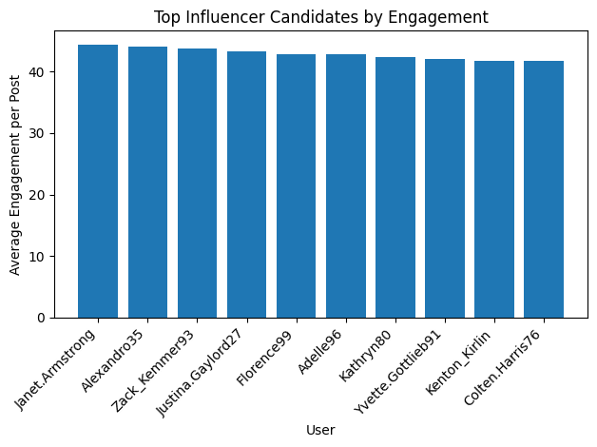

Key observations:
- Janet.Armstrong leads with the highest engagement (~44.4).
- Engagement values are tightly clustered above 41, indicating a strong and reliable influencer group.
- These users outperform others in audience interaction efficiency, making them ideal for brand collaborations.

Why These Users Are Ideal Influencers
- High engagement rate: Their followers actively like and comment.
- Content consistency: Minimum posting threshold ensures reliability.
- Organic reach: Engagement suggests authentic interaction rather than passive followers.
- Cost-effective marketing: Micro and mid-tier influencers often outperform large accounts in conversion.
Q6 Based on user behavior and engagement data, how would you segment the user base for targeted marketing campaigns or personalized recommendations?
WITH posts AS (
SELECT user_id, COUNT(*) posts FROM photos GROUP BY user_id
),
eng AS (
SELECT p.user_id,
COUNT(DISTINCT l.user_id) likes_rec,
COUNT(DISTINCT c.id) comments_rec
FROM photos p
LEFT JOIN likes l ON p.id=l.photo_id
LEFT JOIN comments c ON p.id=c.photo_id
GROUP BY p.user_id
)
SELECT u.id, u.username, posts, (likes_rec+comments_rec) AS engagement
FROM users u
JOIN posts p ON u.id=p.user_id
JOIN eng e ON u.id=e.user_id
WHERE posts>=5
ORDER BY engagement DESC;
OUTPUT:
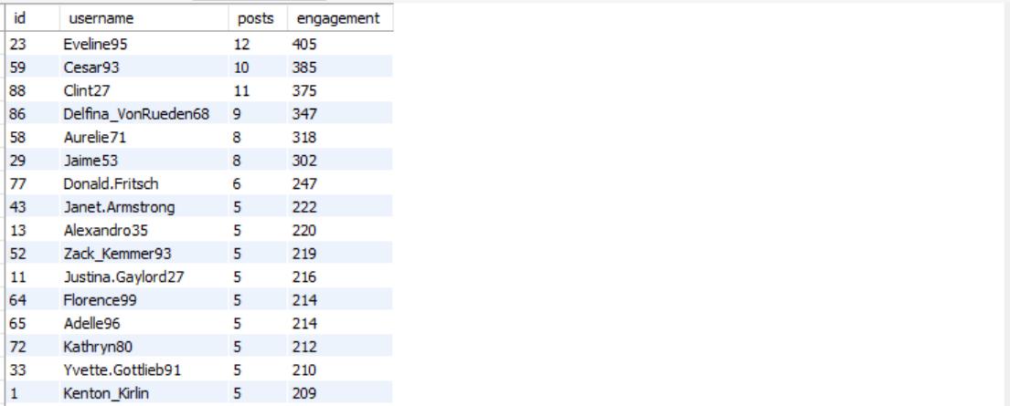

id | username | posts | engagement
23 | Eveline95 | 12 | 405
59 | Cesar93 | 10 | 385
88 | Clint27 | 11 | 375
86 | Delfina_VonRueden68 | 9 | 347
58 | Aurelie71 | 8 | 318
29 | Jaime53 | 8 | 302
77 | Donald.Fritsch | 6 | 247
43 | Janet.Armstrong | 5 | 222
13 | Alexandro35 | 5 | 220
52 | Zack_Kemmer93 | 5 | 219
11 | Justina.Gaylord27 | 5 | 216
64 | Florence99 | 5 | 214
65 | Adelle96 | 5 | 214
72 | Kathryn80 | 5 | 212
33 | Yvette.Gottlieb91 | 5 | 210
1 | Kenton_Kirlin | 5 | 209
78 | Colten.Harris76 | 5 | 209
6 | Travon.Waters | 5 | 208
51 | Mariano_Koch3 | 5 | 208
26 | Josianne.Friesen | 5 | 206
47 | Harrison.Beatty50 | 5 | 206

1. Power Creators (High Content + High Engagement)
Evidence from Data:
- Users like Eveline95, Cesar93, Clint27 have 8–12 posts and 300+ total engagements.
- These users consistently generate content and receive strong audience interaction.
Characteristics:
- High posting frequency
- High likes and comments received
- Strong visibility on the platform
Marketing Strategy:
- Prioritize them for creator partnerships, early feature access, and branded content campaigns.
- Offer incentives such as monetization tools, creator badges, or campaign collaborations.

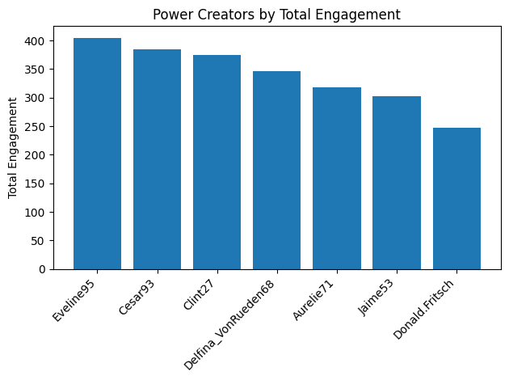

-- Influencer / High-Impact Users (Followers + Engagement Efficiency) --
WITH followers AS (
SELECT followee_id user_id, COUNT(*) followers FROM follows GROUP BY followee_id
),
posts AS (
SELECT user_id, COUNT(*) posts FROM photos GROUP BY user_id
),
eng AS (
SELECT p.user_id,
COUNT(DISTINCT l.user_id)+COUNT(DISTINCT c.id) eng
FROM photos p
LEFT JOIN likes l ON p.id=l.photo_id
LEFT JOIN comments c ON p.id=c.photo_id
GROUP BY p.user_id
)
SELECT u.id,u.username,f.followers, p.posts, ROUND(eng/p.posts,2) avg_eng
FROM users u
JOIN followers f ON u.id=f.user_id
JOIN posts p ON u.id=p.user_id
JOIN eng e ON u.id=e.user_id
WHERE p.posts>=5
ORDER BY avg_eng DESC;
OUTPUT:

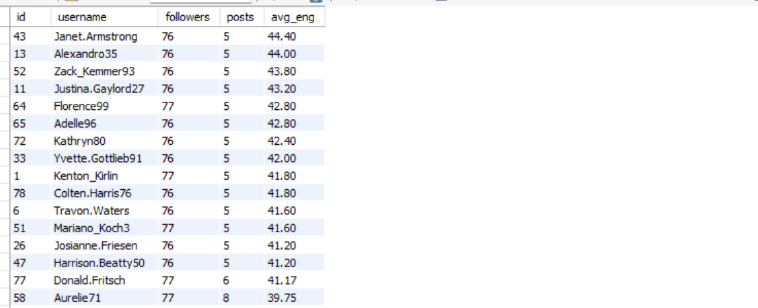

id | username | followers | posts | avg_eng
43 | Janet.Armstrong | 76 | 5 | 44.4
13 | Alexandro35 | 76 | 5 | 44
52 | Zack_Kemmer93 | 76 | 5 | 43.8
11 | Justina.Gaylord27 | 76 | 5 | 43.2
64 | Florence99 | 77 | 5 | 42.8
65 | Adelle96 | 76 | 5 | 42.8
72 | Kathryn80 | 76 | 5 | 42.4
33 | Yvette.Gottlieb91 | 76 | 5 | 42
1 | Kenton_Kirlin | 77 | 5 | 41.8
78 | Colten.Harris76 | 76 | 5 | 41.8
6 | Travon.Waters | 76 | 5 | 41.6
51 | Mariano_Koch3 | 77 | 5 | 41.6
26 | Josianne.Friesen | 76 | 5 | 41.2
47 | Harrison.Beatty50 | 76 | 5 | 41.2
77 | Donald.Fritsch | 77 | 6 | 41.17
58 | Aurelie71 | 77 | 8 | 39.75
86 | Delfina_VonRueden68 | 77 | 9 | 38.56
59 | Cesar93 | 77 | 10 | 38.5
29 | Jaime53 | 77 | 8 | 37.75
88 | Clint27 | 77 | 11 | 34.09
23 | Eveline95 | 77 | 12 | 33.75

2. Micro-Influencers (High Engagement per Post)
Evidence from Data:
- Users such as Janet.Armstrong, Alexandro35, Zack_Kemmer93 show average engagement per post above 40, despite having only ~5 posts.
- Engagement quality is high even with lower content volume.
Characteristics:
- Moderate follower base
- Very high engagement efficiency
- Trusted within niche communities
Marketing Strategy:
- Ideal for niche influencer marketing and targeted ad campaigns.
- Collaborate for product launches, regional promotions, or hashtag-driven challenges.

-- Active Engagers (Non-Creators) --
SELECT u.id,u.username,
COUNT(DISTINCT l.photo_id) likes_given,
COUNT(DISTINCT c.id) comments_made
FROM users u
LEFT JOIN photos p ON u.id=p.user_id
LEFT JOIN likes l ON u.id=l.user_id
LEFT JOIN comments c ON u.id=c.user_id
WHERE p.id IS NULL
GROUP BY u.id,u.username
HAVING likes_given>0 OR comments_made>0;
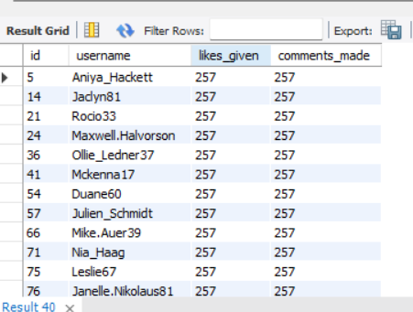

id | username | likes_given | comments_made
5 | Aniya_Hackett | 257 | 257
14 | Jaclyn81 | 257 | 257
21 | Rocio33 | 257 | 257
24 | Maxwell.Halvorson | 257 | 257
36 | Ollie_Ledner37 | 257 | 257
41 | Mckenna17 | 257 | 257
54 | Duane60 | 257 | 257
57 | Julien_Schmidt | 257 | 257
66 | Mike.Auer39 | 257 | 257
71 | Nia_Haag | 257 | 257
75 | Leslie67 | 257 | 257
76 | Janelle.Nikolaus81 | 257 | 257
91 | Bethany20 | 257 | 257

3. Highly Active Engagers (Non-Creators)
Evidence from Data:
- Users like Aniya_Hackett, Jaclyn81, Rocio33 have 250+ likes and comments given, but no posts.
- Strong interaction behavior without content creation.
Characteristics:
- Engage heavily through likes and comments
- High platform stickiness
- No original content posted
Marketing Strategy:
- Encourage content creation using posting prompts, “Your First Post” campaigns, or gamified rewards.
- Recommend content aligned with their top hashtag interests (e.g., smile, beach, party

-- Passive Consumers --
SELECT u.id,u.username
FROM users u
LEFT JOIN photos p ON u.id=p.user_id
LEFT JOIN likes l ON u.id=l.user_id
LEFT JOIN comments c ON u.id=c.user_id
GROUP BY u.id,u.username
HAVING COUNT(p.id)=0 AND COUNT(l.user_id)=0 AND COUNT(c.id)=0;
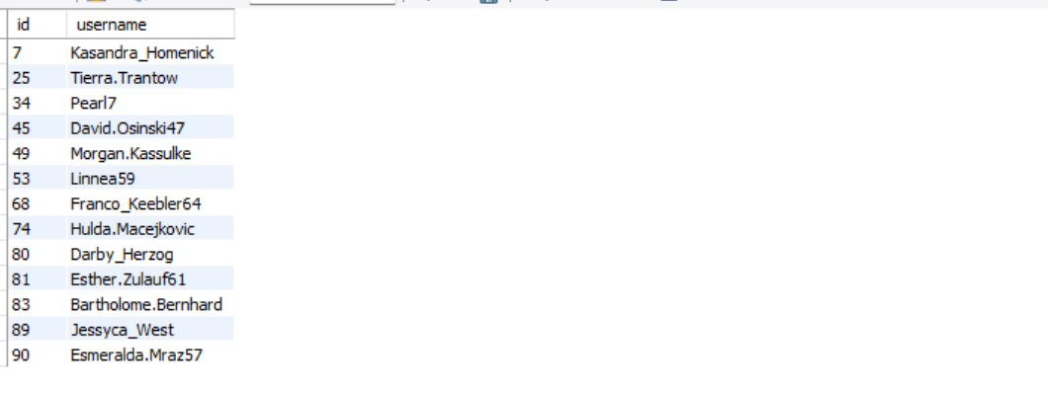
id | username
7 | Kasandra_Homenick
25 | Tierra.Trantow
34 | Pearl7
45 | David.Osinski47
49 | Morgan.Kassulke
53 | Linnea59
68 | Franco_Keebler64
74 | Hulda.Macejkovic
80 | Darby_Herzog
81 | Esther.Zulauf61
83 | Bartholome.Bernhard
89 | Jessyca_West
90 | Esmeralda.Mraz57

4. Passive Consumers (Inactive Users)
Evidence from Data:
- Users such as Kasandra_Homenick, Tierra.Trantow have no posts, likes, or comments.
- Completely inactive on the platform.
Characteristics:
- Low engagement
- High churn risk
Marketing Strategy:
- Run re-engagement campaigns using push notifications, email reminders, or trending content highlights.
- Offer onboarding tutorials or personalized feed previews to spark interest.

-- Content-Interest Segments (Hashtag Affinity) --
SELECT u.id,u.username,t.tag_name,COUNT(*) interactions
FROM users u
JOIN likes l ON u.id=l.user_id
JOIN photo_tags pt ON l.photo_id=pt.photo_id
JOIN tags t ON pt.tag_id=t.id
GROUP BY u.id,u.username,t.tag_name
ORDER BY interactions DESC;

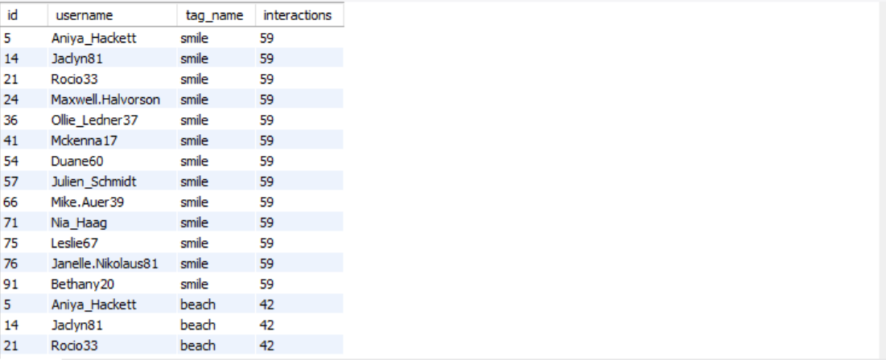

id | username | tag_name | interactions
5 | Aniya_Hackett | smile | 59
14 | Jaclyn81 | smile | 59
21 | Rocio33 | smile | 59
24 | Maxwell.Halvorson | smile | 59
36 | Ollie_Ledner37 | smile | 59
41 | Mckenna17 | smile | 59
54 | Duane60 | smile | 59
57 | Julien_Schmidt | smile | 59
66 | Mike.Auer39 | smile | 59
71 | Nia_Haag | smile | 59
75 | Leslie67 | smile | 59
76 | Janelle.Nikolaus81 | smile | 59
91 | Bethany20 | smile | 59
5 | Aniya_Hackett | beach | 42
14 | Jaclyn81 | beach | 42
21 | Rocio33 | beach | 42
24 | Maxwell.Halvorson | beach | 42
36 | Ollie_Ledner37 | beach | 42
41 | Mckenna17 | beach | 42
54 | Duane60 | beach | 42
57 | Julien_Schmidt | beach | 42
66 | Mike.Auer39 | beach | 42
71 | Nia_Haag | beach | 42
75 | Leslie67 | beach | 42
76 | Janelle.Nikolaus81 | beach | 42
91 | Bethany20 | beach | 42
5 | Aniya_Hackett | party | 39
14 | Jaclyn81 | party | 39
21 | Rocio33 | party | 39
24 | Maxwell.Halvorson | party | 39
36 | Ollie_Ledner37 | party | 39
41 | Mckenna17 | party | 39
54 | Duane60 | party | 39
57 | Julien_Schmidt | party | 39
66 | Mike.Auer39 | party | 39
71 | Nia_Haag | party | 39
75 | Leslie67 | party | 39
76 | Janelle.Nikolaus81 | party | 39
91 | Bethany20 | party | 39
5 | Aniya_Hackett | fun | 38
14 | Jaclyn81 | fun | 38
21 | Rocio33 | fun | 38
24 | Maxwell.Halvorson | fun | 38
36 | Ollie_Ledner37 | fun | 38
41 | Mckenna17 | fun | 38
54 | Duane60 | fun | 38
57 | Julien_Schmidt | fun | 38
66 | Mike.Auer39 | fun | 38
71 | Nia_Haag | fun | 38
75 | Leslie67 | fun | 38
76 | Janelle.Nikolaus81 | fun | 38
91 | Bethany20 | fun | 38
87 | Rick29 | smile | 32
16 | Annalise.McKenzie16 | smile | 28
69 | Karley_Bosco | smile | 26
46 | Malinda_Streich | smile | 25
32 | Irwin.Larson | smile | 25
5 | Aniya_Hackett | concert | 24
14 | Jaclyn81 | concert | 24
21 | Rocio33 | concert | 24
24 | Maxwell.Halvorson | concert | 24
36 | Ollie_Ledner37 | concert | 24
41 | Mckenna17 | concert | 24
54 | Duane60 | concert | 24
57 | Julien_Schmidt | concert | 24
66 | Mike.Auer39 | concert | 24
71 | Nia_Haag | concert | 24
75 | Leslie67 | concert | 24
76 | Janelle.Nikolaus81 | concert | 24
91 | Bethany20 | concert | 24
5 | Aniya_Hackett | food | 24
14 | Jaclyn81 | food | 24
21 | Rocio33 | food | 24
24 | Maxwell.Halvorson | food | 24
36 | Ollie_Ledner37 | food | 24
41 | Mckenna17 | food | 24
54 | Duane60 | food | 24
57 | Julien_Schmidt | food | 24
66 | Mike.Auer39 | food | 24
71 | Nia_Haag | food | 24
75 | Leslie67 | food | 24
76 | Janelle.Nikolaus81 | food | 24
91 | Bethany20 | food | 24
5 | Aniya_Hackett | lol | 24
14 | Jaclyn81 | lol | 24
21 | Rocio33 | lol | 24
24 | Maxwell.Halvorson | lol | 24
36 | Ollie_Ledner37 | lol | 24
41 | Mckenna17 | lol | 24
54 | Duane60 | lol | 24
57 | Julien_Schmidt | lol | 24
66 | Mike.Auer39 | lol | 24
71 | Nia_Haag | lol | 24
75 | Leslie67 | lol | 24
76 | Janelle.Nikolaus81 | lol | 24
91 | Bethany20 | lol | 24
55 | Meggie_Doyle | smile | 24
43 | Janet.Armstrong | smile | 24
92 | Frederik_Rice | smile | 24
44 | Seth46 | smile | 24
50 | Gerard79 | smile | 24
5 | Aniya_Hackett | hair | 23
14 | Jaclyn81 | hair | 23
21 | Rocio33 | hair | 23
24 | Maxwell.Halvorson | hair | 23
36 | Ollie_Ledner37 | hair | 23
41 | Mckenna17 | hair | 23
54 | Duane60 | hair | 23
57 | Julien_Schmidt | hair | 23
66 | Mike.Auer39 | hair | 23
71 | Nia_Haag | hair | 23
75 | Leslie67 | hair | 23
76 | Janelle.Nikolaus81 | hair | 23
91 | Bethany20 | hair | 23
16 | Annalise.McKenzie16 | party | 23
70 | Erick5 | smile | 23
27 | Darwin29 | smile | 23
93 | Willie_Leuschke | smile | 23
94 | Damon35 | smile | 23
6 | Travon.Waters | smile | 23
60 | Sam52 | smile | 23
5 | Aniya_Hackett | happy | 22
14 | Jaclyn81 | happy | 22
21 | Rocio33 | happy | 22
24 | Maxwell.Halvorson | happy | 22
36 | Ollie_Ledner37 | happy | 22
41 | Mckenna17 | happy | 22
54 | Duane60 | happy | 22
57 | Julien_Schmidt | happy | 22
66 | Mike.Auer39 | happy | 22
71 | Nia_Haag | happy | 22
75 | Leslie67 | happy | 22
76 | Janelle.Nikolaus81 | happy | 22
91 | Bethany20 | happy | 22
19 | Hailee26 | smile | 22
78 | Colten.Harris76 | smile | 22
4 | Arely_Bogan63 | smile | 22
15 | Billy52 | smile | 22
73 | Jaylan.Lakin | smile | 22
92 | Frederik_Rice | fun | 21
11 | Justina.Gaylord27 | smile | 21
82 | Aracely.Johnston98 | smile | 21
72 | Kathryn80 | smile | 21
85 | Milford_Gleichner42 | smile | 21
96 | Keenan.Schamberger60 | smile | 21
26 | Josianne.Friesen | smile | 21
26 | Josianne.Friesen | beach | 20
96 | Keenan.Schamberger60 | beach | 20
16 | Annalise.McKenzie16 | beach | 20
5 | Aniya_Hackett | beauty | 20
14 | Jaclyn81 | beauty | 20
21 | Rocio33 | beauty | 20
24 | Maxwell.Halvorson | beauty | 20
36 | Ollie_Ledner37 | beauty | 20
41 | Mckenna17 | beauty | 20
54 | Duane60 | beauty | 20
57 | Julien_Schmidt | beauty | 20
66 | Mike.Auer39 | beauty | 20
71 | Nia_Haag | beauty | 20
75 | Leslie67 | beauty | 20
76 | Janelle.Nikolaus81 | beauty | 20
91 | Bethany20 | beauty | 20
5 | Aniya_Hackett | dreamy | 20
14 | Jaclyn81 | dreamy | 20
21 | Rocio33 | dreamy | 20
24 | Maxwell.Halvorson | dreamy | 20
36 | Ollie_Ledner37 | dreamy | 20
41 | Mckenna17 | dreamy | 20
54 | Duane60 | dreamy | 20
57 | Julien_Schmidt | dreamy | 20
66 | Mike.Auer39 | dreamy | 20
71 | Nia_Haag | dreamy | 20
75 | Leslie67 | dreamy | 20
76 | Janelle.Nikolaus81 | dreamy | 20
91 | Bethany20 | dreamy | 20
32 | Irwin.Larson | fun | 20
60 | Sam52 | fun | 20
2 | Andre_Purdy85 | smile | 20
35 | Lennie_Hartmann40 | smile | 20
20 | Delpha.Kihn | smile | 20
61 | Jayson65 | smile | 20
39 | Kelsi26 | smile | 20
65 | Adelle96 | smile | 20
87 | Rick29 | beach | 19
46 | Malinda_Streich | beach | 19
5 | Aniya_Hackett | drunk | 19
14 | Jaclyn81 | drunk | 19
21 | Rocio33 | drunk | 19
24 | Maxwell.Halvorson | drunk | 19
36 | Ollie_Ledner37 | drunk | 19
41 | Mckenna17 | drunk | 19
54 | Duane60 | drunk | 19
57 | Julien_Schmidt | drunk | 19
66 | Mike.Auer39 | drunk | 19
71 | Nia_Haag | drunk | 19
75 | Leslie67 | drunk | 19
76 | Janelle.Nikolaus81 | drunk | 19
91 | Bethany20 | drunk | 19
5 | Aniya_Hackett | fashion | 19
14 | Jaclyn81 | fashion | 19
21 | Rocio33 | fashion | 19
24 | Maxwell.Halvorson | fashion | 19
36 | Ollie_Ledner37 | fashion | 19
41 | Mckenna17 | fashion | 19
54 | Duane60 | fashion | 19
57 | Julien_Schmidt | fashion | 19
66 | Mike.Auer39 | fashion | 19
71 | Nia_Haag | fashion | 19
75 | Leslie67 | fashion | 19
76 | Janelle.Nikolaus81 | fashion | 19
91 | Bethany20 | fashion | 19
4 | Arely_Bogan63 | fun | 19
35 | Lennie_Hartmann40 | party | 19
17 | Norbert_Carroll35 | smile | 19
56 | Peter.Stehr0 | smile | 19
84 | Alysa22 | smile | 19
38 | Jordyn.Jacobson2 | smile | 19
42 | Maya.Farrell | smile | 19
18 | Odessa2 | smile | 19
5 | Aniya_Hackett | sunset | 19
14 | Jaclyn81 | sunset | 19
21 | Rocio33 | sunset | 19
24 | Maxwell.Halvorson | sunset | 19
36 | Ollie_Ledner37 | sunset | 19
41 | Mckenna17 | sunset | 19
54 | Duane60 | sunset | 19
57 | Julien_Schmidt | sunset | 19
66 | Mike.Auer39 | sunset | 19
71 | Nia_Haag | sunset | 19
75 | Leslie67 | sunset | 19
76 | Janelle.Nikolaus81 | sunset | 19
91 | Bethany20 | sunset | 19
31 | Aiyana_Hoeger | beach | 18
73 | Jaylan.Lakin | beach | 18
85 | Milford_Gleichner42 | beach | 18
70 | Erick5 | party | 18
31 | Aiyana_Hoeger | smile | 18
52 | Zack_Kemmer93 | smile | 18
99 | Alek_Watsica | smile | 18
30 | Kaley9 | smile | 18
40 | Rafael.Hickle2 | smile | 18
8 | Tabitha_Schamberger11 | beach | 17
44 | Seth46 | beach | 17
52 | Zack_Kemmer93 | beach | 17
22 | Kenneth64 | beach | 17
39 | Kelsi26 | beach | 17
19 | Hailee26 | fun | 17
16 | Annalise.McKenzie16 | fun | 17
40 | Rafael.Hickle2 | fun | 17
5 | Aniya_Hackett | landscape | 17
14 | Jaclyn81 | landscape | 17
21 | Rocio33 | landscape | 17
24 | Maxwell.Halvorson | landscape | 17
36 | Ollie_Ledner37 | landscape | 17
41 | Mckenna17 | landscape | 17
54 | Duane60 | landscape | 17
57 | Julien_Schmidt | landscape | 17
66 | Mike.Auer39 | landscape | 17
71 | Nia_Haag | landscape | 17
75 | Leslie67 | landscape | 17
76 | Janelle.Nikolaus81 | landscape | 17
91 | Bethany20 | landscape | 17
69 | Karley_Bosco | party | 17
9 | Gus93 | smile | 17
10 | Presley_McClure | smile | 17
98 | Imani_Nicolas17 | smile | 17
67 | Emilio_Bernier52 | smile | 17
5 | Aniya_Hackett | style | 17
14 | Jaclyn81 | style | 17
21 | Rocio33 | style | 17
24 | Maxwell.Halvorson | style | 17
36 | Ollie_Ledner37 | style | 17
41 | Mckenna17 | style | 17
54 | Duane60 | style | 17
57 | Julien_Schmidt | style | 17
66 | Mike.Auer39 | style | 17
71 | Nia_Haag | style | 17
75 | Leslie67 | style | 17
76 | Janelle.Nikolaus81 | style | 17
91 | Bethany20 | style | 17
5 | Aniya_Hackett | sunrise | 17
14 | Jaclyn81 | sunrise | 17
21 | Rocio33 | sunrise | 17
24 | Maxwell.Halvorson | sunrise | 17
36 | Ollie_Ledner37 | sunrise | 17
41 | Mckenna17 | sunrise | 17
54 | Duane60 | sunrise | 17
57 | Julien_Schmidt | sunrise | 17
66 | Mike.Auer39 | sunrise | 17
71 | Nia_Haag | sunrise | 17
75 | Leslie67 | sunrise | 17
76 | Janelle.Nikolaus81 | sunrise | 17
91 | Bethany20 | sunrise | 17
30 | Kaley9 | beach | 16
69 | Karley_Bosco | beach | 16
10 | Presley_McClure | beach | 16
70 | Erick5 | beach | 16
55 | Meggie_Doyle | fun | 16
43 | Janet.Armstrong | fun | 16
44 | Seth46 | fun | 16
73 | Jaylan.Lakin | fun | 16
55 | Meggie_Doyle | party | 16
78 | Colten.Harris76 | party | 16
26 | Josianne.Friesen | party | 16
5 | Aniya_Hackett | photography | 16
14 | Jaclyn81 | photography | 16
21 | Rocio33 | photography | 16
24 | Maxwell.Halvorson | photography | 16
36 | Ollie_Ledner37 | photography | 16
41 | Mckenna17 | photography | 16
54 | Duane60 | photography | 16
57 | Julien_Schmidt | photography | 16
66 | Mike.Auer39 | photography | 16
71 | Nia_Haag | photography | 16
75 | Leslie67 | photography | 16
76 | Janelle.Nikolaus81 | photography | 16
91 | Bethany20 | photography | 16
12 | Dereck65 | smile | 16
13 | Alexandro35 | smile | 16
62 | Ressie_Stanton46 | smile | 16
100 | Javonte83 | smile | 16
37 | Yazmin_Mills95 | smile | 16
63 | Elenor88 | smile | 16
22 | Kenneth64 | smile | 16
33 | Yvette.Gottlieb91 | smile | 16
8 | Tabitha_Schamberger11 | smile | 16
5 | Aniya_Hackett | stunning | 16
14 | Jaclyn81 | stunning | 16
21 | Rocio33 | stunning | 16
24 | Maxwell.Halvorson | stunning | 16
36 | Ollie_Ledner37 | stunning | 16
41 | Mckenna17 | stunning | 16
54 | Duane60 | stunning | 16
57 | Julien_Schmidt | stunning | 16
66 | Mike.Auer39 | stunning | 16
71 | Nia_Haag | stunning | 16
75 | Leslie67 | stunning | 16
76 | Janelle.Nikolaus81 | stunning | 16
91 | Bethany20 | stunning | 16
6 | Travon.Waters | beach | 15
19 | Hailee26 | beach | 15
38 | Jordyn.Jacobson2 | beach | 15
56 | Peter.Stehr0 | beach | 15
11 | Justina.Gaylord27 | beach | 15
13 | Alexandro35 | beach | 15
35 | Lennie_Hartmann40 | beach | 15
37 | Yazmin_Mills95 | beach | 15
42 | Maya.Farrell | beach | 15
79 | Katarina.Dibbert | beach | 15
65 | Adelle96 | beach | 15
60 | Sam52 | beach | 15
93 | Willie_Leuschke | beach | 15
55 | Meggie_Doyle | beach | 15
5 | Aniya_Hackett | delicious | 15
14 | Jaclyn81 | delicious | 15
21 | Rocio33 | delicious | 15
24 | Maxwell.Halvorson | delicious | 15
36 | Ollie_Ledner37 | delicious | 15
41 | Mckenna17 | delicious | 15
54 | Duane60 | delicious | 15
57 | Julien_Schmidt | delicious | 15
66 | Mike.Auer39 | delicious | 15
71 | Nia_Haag | delicious | 15
75 | Leslie67 | delicious | 15
76 | Janelle.Nikolaus81 | delicious | 15
91 | Bethany20 | delicious | 15
42 | Maya.Farrell | food | 15
8 | Tabitha_Schamberger11 | food | 15
11 | Justina.Gaylord27 | fun | 15
35 | Lennie_Hartmann40 | fun | 15
78 | Colten.Harris76 | fun | 15
82 | Aracely.Johnston98 | fun | 15
87 | Rick29 | fun | 15
27 | Darwin29 | fun | 15
48 | Granville_Kutch | fun | 15
6 | Travon.Waters | party | 15
32 | Irwin.Larson | party | 15
22 | Kenneth64 | party | 15
65 | Adelle96 | party | 15
15 | Billy52 | party | 15
39 | Kelsi26 | party | 15
47 | Harrison.Beatty50 | smile | 15
3 | Harley_Lind18 | smile | 15
97 | Tomas.Beatty93 | smile | 15
95 | Nicole71 | smile | 15
3 | Harley_Lind18 | beach | 14
40 | Rafael.Hickle2 | beach | 14
62 | Ressie_Stanton46 | beach | 14
28 | Dario77 | beach | 14
32 | Irwin.Larson | beach | 14
18 | Odessa2 | beach | 14
20 | Delpha.Kihn | beach | 14
100 | Javonte83 | beach | 14
16 | Annalise.McKenzie16 | concert | 14
69 | Karley_Bosco | fun | 14
99 | Alek_Watsica | fun | 14
61 | Jayson65 | fun | 14
26 | Josianne.Friesen | fun | 14
10 | Presley_McClure | party | 14
4 | Arely_Bogan63 | party | 14
92 | Frederik_Rice | party | 14
38 | Jordyn.Jacobson2 | party | 14
93 | Willie_Leuschke | party | 14
52 | Zack_Kemmer93 | party | 14
73 | Jaylan.Lakin | party | 14
13 | Alexandro35 | party | 14
67 | Emilio_Bernier52 | party | 14
72 | Kathryn80 | party | 14
28 | Dario77 | smile | 14
63 | Elenor88 | beach | 13
92 | Frederik_Rice | beach | 13
43 | Janet.Armstrong | beach | 13
72 | Kathryn80 | beach | 13
2 | Andre_Purdy85 | beach | 13
87 | Rick29 | beauty | 13
55 | Meggie_Doyle | concert | 13
16 | Annalise.McKenzie16 | food | 13
93 | Willie_Leuschke | fun | 13
39 | Kelsi26 | fun | 13
97 | Tomas.Beatty93 | fun | 13
6 | Travon.Waters | fun | 13
18 | Odessa2 | fun | 13
4 | Arely_Bogan63 | happy | 13
43 | Janet.Armstrong | lol | 13
99 | Alek_Watsica | lol | 13
32 | Irwin.Larson | lol | 13
9 | Gus93 | party | 13
11 | Justina.Gaylord27 | party | 13
46 | Malinda_Streich | party | 13
47 | Harrison.Beatty50 | party | 13
17 | Norbert_Carroll35 | party | 13
43 | Janet.Armstrong | party | 13
30 | Kaley9 | party | 13
31 | Aiyana_Hoeger | party | 13
62 | Ressie_Stanton46 | party | 13
87 | Rick29 | party | 13
8 | Tabitha_Schamberger11 | party | 13
20 | Delpha.Kihn | party | 13
40 | Rafael.Hickle2 | party | 13
48 | Granville_Kutch | party | 13
84 | Alysa22 | party | 13
79 | Katarina.Dibbert | smile | 13
48 | Granville_Kutch | smile | 13
17 | Norbert_Carroll35 | beach | 12
94 | Damon35 | beach | 12
95 | Nicole71 | beach | 12
61 | Jayson65 | beach | 12
84 | Alysa22 | beach | 12
97 | Tomas.Beatty93 | beach | 12
78 | Colten.Harris76 | beach | 12
50 | Gerard79 | beach | 12
46 | Malinda_Streich | beauty | 12
16 | Annalise.McKenzie16 | beauty | 12
46 | Malinda_Streich | fun | 12
15 | Billy52 | fun | 12
20 | Delpha.Kihn | fun | 12
56 | Peter.Stehr0 | fun | 12
72 | Kathryn80 | fun | 12
85 | Milford_Gleichner42 | fun | 12
96 | Keenan.Schamberger60 | fun | 12
38 | Jordyn.Jacobson2 | fun | 12
63 | Elenor88 | fun | 12
65 | Adelle96 | fun | 12
67 | Emilio_Bernier52 | fun | 12
13 | Alexandro35 | hair | 12
43 | Janet.Armstrong | happy | 12
92 | Frederik_Rice | lol | 12
96 | Keenan.Schamberger60 | lol | 12
19 | Hailee26 | party | 12
82 | Aracely.Johnston98 | party | 12
37 | Yazmin_Mills95 | party | 12
94 | Damon35 | party | 12
100 | Javonte83 | party | 12
97 | Tomas.Beatty93 | party | 12
79 | Katarina.Dibbert | party | 12
60 | Sam52 | party | 12
56 | Peter.Stehr0 | party | 12
13 | Alexandro35 | sunset | 12
33 | Yvette.Gottlieb91 | beach | 11
9 | Gus93 | beach | 11
99 | Alek_Watsica | beach | 11
61 | Jayson65 | beauty | 11
70 | Erick5 | beauty | 11
35 | Lennie_Hartmann40 | concert | 11
48 | Granville_Kutch | concert | 11
73 | Jaylan.Lakin | concert | 11
4 | Arely_Bogan63 | concert | 11
65 | Adelle96 | concert | 11
70 | Erick5 | concert | 11
92 | Frederik_Rice | concert | 11
35 | Lennie_Hartmann40 | delicious | 11
16 | Annalise.McKenzie16 | dreamy | 11
26 | Josianne.Friesen | dreamy | 11
87 | Rick29 | dreamy | 11
16 | Annalise.McKenzie16 | drunk | 11
11 | Justina.Gaylord27 | fashion | 11
78 | Colten.Harris76 | fashion | 11
4 | Arely_Bogan63 | food | 11
69 | Karley_Bosco | food | 11
35 | Lennie_Hartmann40 | food | 11
47 | Harrison.Beatty50 | food | 11
65 | Adelle96 | food | 11
5 | Aniya_Hackett | foodie | 11
14 | Jaclyn81 | foodie | 11
21 | Rocio33 | foodie | 11
24 | Maxwell.Halvorson | foodie | 11
36 | Ollie_Ledner37 | foodie | 11
41 | Mckenna17 | foodie | 11
54 | Duane60 | foodie | 11
57 | Julien_Schmidt | foodie | 11
66 | Mike.Auer39 | foodie | 11
71 | Nia_Haag | foodie | 11
75 | Leslie67 | foodie | 11
76 | Janelle.Nikolaus81 | foodie | 11
91 | Bethany20 | foodie | 11
13 | Alexandro35 | fun | 11
17 | Norbert_Carroll35 | fun | 11
70 | Erick5 | fun | 11
84 | Alysa22 | fun | 11
30 | Kaley9 | fun | 11
37 | Yazmin_Mills95 | fun | 11
98 | Imani_Nicolas17 | fun | 11
33 | Yvette.Gottlieb91 | fun | 11
6 | Travon.Waters | hair | 11
78 | Colten.Harris76 | hair | 11
16 | Annalise.McKenzie16 | hair | 11
22 | Kenneth64 | hair | 11
84 | Alysa22 | hair | 11
15 | Billy52 | happy | 11
92 | Frederik_Rice | happy | 11
50 | Gerard79 | happy | 11
93 | Willie_Leuschke | happy | 11
32 | Irwin.Larson | happy | 11
82 | Aracely.Johnston98 | happy | 11
4 | Arely_Bogan63 | lol | 11
13 | Alexandro35 | lol | 11
44 | Seth46 | lol | 11
33 | Yvette.Gottlieb91 | party | 11
42 | Maya.Farrell | party | 11
61 | Jayson65 | party | 11
85 | Milford_Gleichner42 | party | 11
18 | Odessa2 | party | 11
63 | Elenor88 | party | 11
12 | Dereck65 | party | 11
87 | Rick29 | stunning | 11
79 | Katarina.Dibbert | sunset | 11
27 | Darwin29 | beach | 10
82 | Aracely.Johnston98 | beach | 10
48 | Granville_Kutch | beach | 10
47 | Harrison.Beatty50 | beach | 10
4 | Arely_Bogan63 | beach | 10
67 | Emilio_Bernier52 | beach | 10
37 | Yazmin_Mills95 | beauty | 10
69 | Karley_Bosco | concert | 10
15 | Billy52 | concert | 10
60 | Sam52 | concert | 10
93 | Willie_Leuschke | concert | 10
19 | Hailee26 | dreamy | 10
27 | Darwin29 | dreamy | 10
44 | Seth46 | dreamy | 10
46 | Malinda_Streich | dreamy | 10
56 | Peter.Stehr0 | dreamy | 10
39 | Kelsi26 | dreamy | 10
96 | Keenan.Schamberger60 | dreamy | 10
60 | Sam52 | drunk | 10
6 | Travon.Waters | food | 10
20 | Delpha.Kihn | food | 10
31 | Aiyana_Hoeger | food | 10
40 | Rafael.Hickle2 | food | 10
72 | Kathryn80 | food | 10
95 | Nicole71 | food | 10
9 | Gus93 | food | 10
32 | Irwin.Larson | food | 10
2 | Andre_Purdy85 | fun | 10
31 | Aiyana_Hoeger | fun | 10
52 | Zack_Kemmer93 | fun | 10
94 | Damon35 | fun | 10
100 | Javonte83 | fun | 10
3 | Harley_Lind18 | fun | 10
50 | Gerard79 | fun | 10
42 | Maya.Farrell | fun | 10
4 | Arely_Bogan63 | hair | 10
11 | Justina.Gaylord27 | hair | 10
42 | Maya.Farrell | hair | 10
15 | Billy52 | hair | 10
69 | Karley_Bosco | hair | 10
79 | Katarina.Dibbert | hair | 10
87 | Rick29 | hair | 10
67 | Emilio_Bernier52 | hair | 10
10 | Presley_McClure | hair | 10
100 | Javonte83 | hair | 10
46 | Malinda_Streich | happy | 10
44 | Seth46 | happy | 10
67 | Emilio_Bernier52 | happy | 10
60 | Sam52 | happy | 10
69 | Karley_Bosco | happy | 10
22 | Kenneth64 | landscape | 10
20 | Delpha.Kihn | lol | 10
85 | Milford_Gleichner42 | lol | 10
93 | Willie_Leuschke | lol | 10
97 | Tomas.Beatty93 | lol | 10
94 | Damon35 | lol | 10
99 | Alek_Watsica | party | 10
50 | Gerard79 | party | 10
3 | Harley_Lind18 | party | 10
8 | Tabitha_Schamberger11 | photography | 10
79 | Katarina.Dibbert | photography | 10
16 | Annalise.McKenzie16 | stunning | 10
26 | Josianne.Friesen | stunning | 10
37 | Yazmin_Mills95 | sunset | 10
55 | Meggie_Doyle | sunset | 10
15 | Billy52 | beach | 9
28 | Dario77 | beauty | 9
93 | Willie_Leuschke | beauty | 9
22 | Kenneth64 | beauty | 9
94 | Damon35 | beauty | 9
39 | Kelsi26 | beauty | 9
31 | Aiyana_Hoeger | beauty | 9
46 | Malinda_Streich | concert | 9
47 | Harrison.Beatty50 | concert | 9
78 | Colten.Harris76 | concert | 9
82 | Aracely.Johnston98 | concert | 9
3 | Harley_Lind18 | concert | 9
26 | Josianne.Friesen | concert | 9
30 | Kaley9 | concert | 9
44 | Seth46 | concert | 9
12 | Dereck65 | concert | 9
38 | Jordyn.Jacobson2 | concert | 9
87 | Rick29 | concert | 9
17 | Norbert_Carroll35 | concert | 9
32 | Irwin.Larson | concert | 9
40 | Rafael.Hickle2 | concert | 9
39 | Kelsi26 | concert | 9
4 | Arely_Bogan63 | delicious | 9
16 | Annalise.McKenzie16 | delicious | 9
9 | Gus93 | delicious | 9
42 | Maya.Farrell | delicious | 9
32 | Irwin.Larson | dreamy | 9
60 | Sam52 | dreamy | 9
3 | Harley_Lind18 | dreamy | 9
52 | Zack_Kemmer93 | dreamy | 9
73 | Jaylan.Lakin | dreamy | 9
50 | Gerard79 | dreamy | 9
28 | Dario77 | dreamy | 9
69 | Karley_Bosco | drunk | 9
27 | Darwin29 | drunk | 9
38 | Jordyn.Jacobson2 | drunk | 9
52 | Zack_Kemmer93 | drunk | 9
73 | Jaylan.Lakin | drunk | 9
92 | Frederik_Rice | drunk | 9
33 | Yvette.Gottlieb91 | fashion | 9
42 | Maya.Farrell | fashion | 9
16 | Annalise.McKenzie16 | fashion | 9
30 | Kaley9 | fashion | 9
69 | Karley_Bosco | fashion | 9
13 | Alexandro35 | fashion | 9
13 | Alexandro35 | food | 9
61 | Jayson65 | food | 9
94 | Damon35 | food | 9
26 | Josianne.Friesen | food | 9
33 | Yvette.Gottlieb91 | food | 9
39 | Kelsi26 | food | 9
87 | Rick29 | food | 9
100 | Javonte83 | food | 9
9 | Gus93 | fun | 9
47 | Harrison.Beatty50 | fun | 9
12 | Dereck65 | fun | 9
22 | Kenneth64 | fun | 9
79 | Katarina.Dibbert | fun | 9
95 | Nicole71 | fun | 9
8 | Tabitha_Schamberger11 | fun | 9
26 | Josianne.Friesen | hair | 9
30 | Kaley9 | hair | 9
52 | Zack_Kemmer93 | hair | 9
65 | Adelle96 | hair | 9
3 | Harley_Lind18 | hair | 9
62 | Ressie_Stanton46 | hair | 9
93 | Willie_Leuschke | hair | 9
70 | Erick5 | hair | 9
20 | Delpha.Kihn | happy | 9
87 | Rick29 | happy | 9
99 | Alek_Watsica | happy | 9
19 | Hailee26 | happy | 9
97 | Tomas.Beatty93 | happy | 9
94 | Damon35 | happy | 9
6 | Travon.Waters | landscape | 9
44 | Seth46 | landscape | 9
17 | Norbert_Carroll35 | lol | 9
31 | Aiyana_Hoeger | lol | 9
78 | Colten.Harris76 | lol | 9
87 | Rick29 | lol | 9
50 | Gerard79 | lol | 9
33 | Yvette.Gottlieb91 | lol | 9
42 | Maya.Farrell | lol | 9
67 | Emilio_Bernier52 | lol | 9
22 | Kenneth64 | lol | 9
40 | Rafael.Hickle2 | lol | 9
8 | Tabitha_Schamberger11 | lol | 9
2 | Andre_Purdy85 | party | 9
98 | Imani_Nicolas17 | party | 9
26 | Josianne.Friesen | photography | 9
78 | Colten.Harris76 | style | 9
79 | Katarina.Dibbert | sunrise | 9
35 | Lennie_Hartmann40 | sunset | 9
48 | Granville_Kutch | sunset | 9
92 | Frederik_Rice | sunset | 9
22 | Kenneth64 | sunset | 9
8 | Tabitha_Schamberger11 | sunset | 9
98 | Imani_Nicolas17 | beach | 8
12 | Dereck65 | beach | 8
27 | Darwin29 | beauty | 8
44 | Seth46 | beauty | 8
52 | Zack_Kemmer93 | beauty | 8
65 | Adelle96 | beauty | 8
69 | Karley_Bosco | beauty | 8
19 | Hailee26 | beauty | 8
35 | Lennie_Hartmann40 | beauty | 8
84 | Alysa22 | beauty | 8
3 | Harley_Lind18 | beauty | 8
26 | Josianne.Friesen | beauty | 8
73 | Jaylan.Lakin | beauty | 8
62 | Ressie_Stanton46 | beauty | 8
96 | Keenan.Schamberger60 | beauty | 8
11 | Justina.Gaylord27 | concert | 8
6 | Travon.Waters | concert | 8
50 | Gerard79 | concert | 8
27 | Darwin29 | concert | 8
61 | Jayson65 | concert | 8
63 | Elenor88 | concert | 8
85 | Milford_Gleichner42 | concert | 8
20 | Delpha.Kihn | concert | 8
72 | Kathryn80 | concert | 8
63 | Elenor88 | delicious | 8
31 | Aiyana_Hoeger | delicious | 8
65 | Adelle96 | delicious | 8
10 | Presley_McClure | dreamy | 8
35 | Lennie_Hartmann40 | dreamy | 8
78 | Colten.Harris76 | dreamy | 8
84 | Alysa22 | dreamy | 8
94 | Damon35 | dreamy | 8
100 | Javonte83 | dreamy | 8
30 | Kaley9 | dreamy | 8
62 | Ressie_Stanton46 | dreamy | 8
85 | Milford_Gleichner42 | dreamy | 8
18 | Odessa2 | dreamy | 8
31 | Aiyana_Hoeger | dreamy | 8
35 | Lennie_Hartmann40 | drunk | 8
55 | Meggie_Doyle | drunk | 8
78 | Colten.Harris76 | drunk | 8
4 | Arely_Bogan63 | drunk | 8
70 | Erick5 | drunk | 8
18 | Odessa2 | drunk | 8
40 | Rafael.Hickle2 | drunk | 8
39 | Kelsi26 | drunk | 8
4 | Arely_Bogan63 | fashion | 8
6 | Travon.Waters | fashion | 8
28 | Dario77 | fashion | 8
8 | Tabitha_Schamberger11 | fashion | 8
10 | Presley_McClure | fashion | 8
18 | Odessa2 | fashion | 8
67 | Emilio_Bernier52 | fashion | 8
100 | Javonte83 | fashion | 8
38 | Jordyn.Jacobson2 | food | 8
50 | Gerard79 | food | 8
85 | Milford_Gleichner42 | food | 8
92 | Frederik_Rice | food | 8
46 | Malinda_Streich | food | 8
2 | Andre_Purdy85 | food | 8
3 | Harley_Lind18 | food | 8
18 | Odessa2 | food | 8
63 | Elenor88 | food | 8
43 | Janet.Armstrong | food | 8
44 | Seth46 | food | 8
96 | Keenan.Schamberger60 | food | 8
37 | Yazmin_Mills95 | food | 8
35 | Lennie_Hartmann40 | foodie | 8
10 | Presley_McClure | fun | 8
62 | Ressie_Stanton46 | fun | 8
28 | Dario77 | hair | 8
37 | Yazmin_Mills95 | hair | 8
43 | Janet.Armstrong | hair | 8
8 | Tabitha_Schamberger11 | hair | 8
31 | Aiyana_Hoeger | hair | 8
35 | Lennie_Hartmann40 | hair | 8
20 | Delpha.Kihn | hair | 8
46 | Malinda_Streich | hair | 8
18 | Odessa2 | hair | 8
12 | Dereck65 | hair | 8
48 | Granville_Kutch | hair | 8
56 | Peter.Stehr0 | hair | 8
56 | Peter.Stehr0 | happy | 8
78 | Colten.Harris76 | happy | 8
96 | Keenan.Schamberger60 | happy | 8
26 | Josianne.Friesen | happy | 8
35 | Lennie_Hartmann40 | happy | 8
55 | Meggie_Doyle | happy | 8
6 | Travon.Waters | happy | 8
33 | Yvette.Gottlieb91 | happy | 8
42 | Maya.Farrell | happy | 8
40 | Rafael.Hickle2 | happy | 8
40 | Rafael.Hickle2 | landscape | 8
56 | Peter.Stehr0 | landscape | 8
2 | Andre_Purdy85 | landscape | 8
13 | Alexandro35 | landscape | 8
43 | Janet.Armstrong | landscape | 8
60 | Sam52 | landscape | 8
55 | Meggie_Doyle | landscape | 8
2 | Andre_Purdy85 | lol | 8
15 | Billy52 | lol | 8
56 | Peter.Stehr0 | lol | 8
84 | Alysa22 | lol | 8
37 | Yazmin_Mills95 | lol | 8
39 | Kelsi26 | lol | 8
55 | Meggie_Doyle | lol | 8
60 | Sam52 | lol | 8
100 | Javonte83 | lol | 8
82 | Aracely.Johnston98 | lol | 8
48 | Granville_Kutch | lol | 8
18 | Odessa2 | lol | 8
44 | Seth46 | party | 8
27 | Darwin29 | party | 8
31 | Aiyana_Hoeger | photography | 8
2 | Andre_Purdy85 | photography | 8
22 | Kenneth64 | photography | 8
85 | Milford_Gleichner42 | photography | 8
27 | Darwin29 | stunning | 8
56 | Peter.Stehr0 | stunning | 8
70 | Erick5 | stunning | 8
60 | Sam52 | stunning | 8
69 | Karley_Bosco | stunning | 8
26 | Josianne.Friesen | style | 8
42 | Maya.Farrell | style | 8
3 | Harley_Lind18 | style | 8
20 | Delpha.Kihn | style | 8
67 | Emilio_Bernier52 | style | 8
100 | Javonte83 | style | 8
15 | Billy52 | style | 8
38 | Jordyn.Jacobson2 | style | 8
70 | Erick5 | style | 8
69 | Karley_Bosco | style | 8
46 | Malinda_Streich | style | 8
6 | Travon.Waters | sunrise | 8
26 | Josianne.Friesen | sunrise | 8
40 | Rafael.Hickle2 | sunrise | 8
96 | Keenan.Schamberger60 | sunrise | 8
16 | Annalise.McKenzie16 | sunrise | 8
13 | Alexandro35 | sunrise | 8
16 | Annalise.McKenzie16 | sunset | 8
42 | Maya.Farrell | sunset | 8
40 | Rafael.Hickle2 | sunset | 8
63 | Elenor88 | sunset | 8
65 | Adelle96 | sunset | 8
67 | Emilio_Bernier52 | sunset | 8
46 | Malinda_Streich | sunset | 8
43 | Janet.Armstrong | beauty | 7
60 | Sam52 | beauty | 7
100 | Javonte83 | beauty | 7
2 | Andre_Purdy85 | beauty | 7
10 | Presley_McClure | beauty | 7
17 | Norbert_Carroll35 | beauty | 7
78 | Colten.Harris76 | beauty | 7
92 | Frederik_Rice | beauty | 7
38 | Jordyn.Jacobson2 | beauty | 7
11 | Justina.Gaylord27 | beauty | 7
2 | Andre_Purdy85 | concert | 7
9 | Gus93 | concert | 7
10 | Presley_McClure | concert | 7
19 | Hailee26 | concert | 7
56 | Peter.Stehr0 | concert | 7
62 | Ressie_Stanton46 | concert | 7
79 | Katarina.Dibbert | concert | 7
96 | Keenan.Schamberger60 | concert | 7
37 | Yazmin_Mills95 | concert | 7
98 | Imani_Nicolas17 | concert | 7
99 | Alek_Watsica | concert | 7
18 | Odessa2 | concert | 7
13 | Alexandro35 | delicious | 7
32 | Irwin.Larson | delicious | 7
47 | Harrison.Beatty50 | delicious | 7
87 | Rick29 | delicious | 7
15 | Billy52 | delicious | 7
95 | Nicole71 | delicious | 7
13 | Alexandro35 | dreamy | 7
69 | Karley_Bosco | dreamy | 7
98 | Imani_Nicolas17 | dreamy | 7
8 | Tabitha_Schamberger11 | dreamy | 7
70 | Erick5 | dreamy | 7
12 | Dereck65 | dreamy | 7
11 | Justina.Gaylord27 | dreamy | 7
93 | Willie_Leuschke | dreamy | 7
46 | Malinda_Streich | drunk | 7
32 | Irwin.Larson | drunk | 7
61 | Jayson65 | drunk | 7
87 | Rick29 | drunk | 7
20 | Delpha.Kihn | drunk | 7
48 | Granville_Kutch | drunk | 7
65 | Adelle96 | drunk | 7
72 | Kathryn80 | drunk | 7
26 | Josianne.Friesen | fashion | 7
82 | Aracely.Johnston98 | fashion | 7
22 | Kenneth64 | fashion | 7
52 | Zack_Kemmer93 | fashion | 7
65 | Adelle96 | fashion | 7
79 | Katarina.Dibbert | fashion | 7
84 | Alysa22 | fashion | 7
3 | Harley_Lind18 | fashion | 7
52 | Zack_Kemmer93 | food | 7
55 | Meggie_Doyle | food | 7
62 | Ressie_Stanton46 | food | 7
67 | Emilio_Bernier52 | food | 7
15 | Billy52 | food | 7
19 | Hailee26 | food | 7
11 | Justina.Gaylord27 | food | 7
8 | Tabitha_Schamberger11 | foodie | 7
9 | Gus93 | foodie | 7
42 | Maya.Farrell | foodie | 7
28 | Dario77 | fun | 7
33 | Yvette.Gottlieb91 | hair | 7
82 | Aracely.Johnston98 | hair | 7
92 | Frederik_Rice | hair | 7
39 | Kelsi26 | hair | 7
97 | Tomas.Beatty93 | hair | 7
98 | Imani_Nicolas17 | hair | 7
9 | Gus93 | hair | 7
94 | Damon35 | hair | 7
13 | Alexandro35 | happy | 7
17 | Norbert_Carroll35 | happy | 7
31 | Aiyana_Hoeger | happy | 7
52 | Zack_Kemmer93 | happy | 7
72 | Kathryn80 | happy | 7
85 | Milford_Gleichner42 | happy | 7
16 | Annalise.McKenzie16 | happy | 7
98 | Imani_Nicolas17 | happy | 7
18 | Odessa2 | happy | 7
100 | Javonte83 | happy | 7
8 | Tabitha_Schamberger11 | happy | 7
8 | Tabitha_Schamberger11 | landscape | 7
31 | Aiyana_Hoeger | landscape | 7
38 | Jordyn.Jacobson2 | landscape | 7
62 | Ressie_Stanton46 | landscape | 7
63 | Elenor88 | landscape | 7
96 | Keenan.Schamberger60 | landscape | 7
16 | Annalise.McKenzie16 | landscape | 7
79 | Katarina.Dibbert | landscape | 7
85 | Milford_Gleichner42 | landscape | 7
11 | Justina.Gaylord27 | lol | 7
28 | Dario77 | lol | 7
46 | Malinda_Streich | lol | 7
72 | Kathryn80 | lol | 7
19 | Hailee26 | lol | 7
63 | Elenor88 | lol | 7
98 | Imani_Nicolas17 | lol | 7
69 | Karley_Bosco | lol | 7
95 | Nicole71 | lol | 7
28 | Dario77 | party | 7
44 | Seth46 | photography | 7
62 | Ressie_Stanton46 | photography | 7
63 | Elenor88 | photography | 7
96 | Keenan.Schamberger60 | photography | 7
4 | Arely_Bogan63 | photography | 7
10 | Presley_McClure | photography | 7
70 | Erick5 | photography | 7
11 | Justina.Gaylord27 | photography | 7
100 | Javonte83 | photography | 7
3 | Harley_Lind18 | stunning | 7
8 | Tabitha_Schamberger11 | stunning | 7
52 | Zack_Kemmer93 | stunning | 7
30 | Kaley9 | stunning | 7
94 | Damon35 | stunning | 7
46 | Malinda_Streich | stunning | 7
32 | Irwin.Larson | stunning | 7
85 | Milford_Gleichner42 | stunning | 7
96 | Keenan.Schamberger60 | stunning | 7
31 | Aiyana_Hoeger | stunning | 7
4 | Arely_Bogan63 | style | 7
28 | Dario77 | style | 7
33 | Yvette.Gottlieb91 | style | 7
10 | Presley_McClure | style | 7
16 | Annalise.McKenzie16 | style | 7
19 | Hailee26 | style | 7
22 | Kenneth64 | style | 7
84 | Alysa22 | style | 7
2 | Andre_Purdy85 | style | 7
79 | Katarina.Dibbert | style | 7
30 | Kaley9 | style | 7
13 | Alexandro35 | style | 7
8 | Tabitha_Schamberger11 | sunrise | 7
30 | Kaley9 | sunrise | 7
33 | Yvette.Gottlieb91 | sunrise | 7
62 | Ressie_Stanton46 | sunrise | 7
63 | Elenor88 | sunrise | 7
87 | Rick29 | sunrise | 7
92 | Frederik_Rice | sunrise | 7
95 | Nicole71 | sunrise | 7
22 | Kenneth64 | sunrise | 7
43 | Janet.Armstrong | sunrise | 7
73 | Jaylan.Lakin | sunrise | 7
11 | Justina.Gaylord27 | sunrise | 7
47 | Harrison.Beatty50 | sunrise | 7
2 | Andre_Purdy85 | sunrise | 7

5. Interest-Based Segments (Hashtag Affinity)
Evidence from Data:
- Strong recurring engagement around hashtags like #smile, #beach, #party, #fun, #concert.
- Same users repeatedly engage with the same themes.
Characteristics:
- Clear content preferences
- Predictable engagement behavior
Marketing Strategy:
- Use hashtag affinity for personalized feed ranking and interest-based ads.
- Target ads and recommendations based on dominant content themes users interact with most.
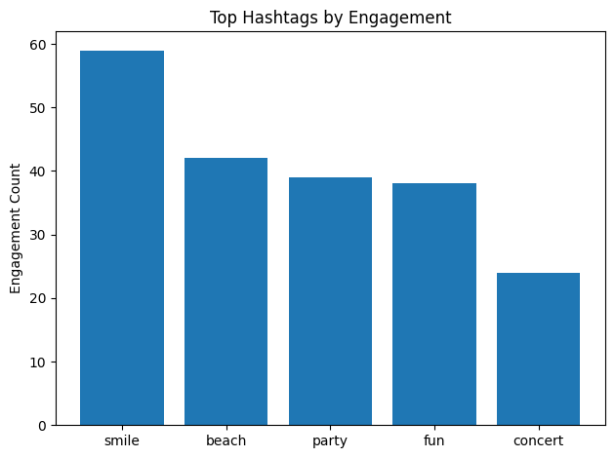

Q7 If data on ad campaigns (impressions, clicks, conversions) is available, how would you measure their effectiveness and optimize future campaigns?

Approach to Measuring Ad Campaign Effectiveness
If ad campaign data such as impressions, clicks, conversions, and engagement is available, campaign effectiveness can be evaluated using a combination of performance metrics, user behavior analysis, and segmentation insights.

Key Metrics to Measure Effectiveness
- Click-Through Rate (CTR)
  - Measures how attractive the ad is.
  - Formula:
CTR = (Clicks / Impressions) × 100
  - A high CTR indicates strong creatives, captions, or targeting.
- Conversion Rate (CVR)
  - Measures how well clicks translate into desired actions (sign-ups, installs, purchases).
  - Formula:
Conversion Rate = (Conversions / Clicks) × 100
  - Helps assess landing page and offer effectiveness.
- Cost per Conversion (if cost data exists)
  - Indicates campaign efficiency.
  - Lower cost per conversion implies better ROI.
- Engagement Rate (Likes, Comments, Shares)
  - Measures how users interact with ads.
  - Useful for brand-awareness campaigns where conversions are not the main goal.
- Reach vs Frequency
  - Ensures ads are not over-shown to the same users.
  - High frequency with low engagement indicates ad fatigue.

Behavior-Based Performance Analysis
By combining ad data with user activity data, deeper insights can be derived:
- Identify which user segments convert the most (highly active users, influencers, content creators).
- Analyze time-based performance (ads performing better on weekends or evenings).
- Compare performance across content themes or hashtags used in ads.
- Measure repeat engagement or conversions from the same users.

Optimization Strategies for Future Campaigns
- Audience Targeting Optimization
  - Retarget highly engaged users (users who like, comment, or follow creators).
  - Exclude inactive users from conversion-focused campaigns.
  - Create look-alike audiences based on high-converting users.
- Creative Optimization
  - Use creatives similar to high-engagement organic posts.
  - Align ad content with trending hashtags and topics (e.g., food, lifestyle, travel).
  - Rotate creatives regularly to avoid ad fatigue.
- Placement & Timing Optimization
  - Schedule ads during peak engagement hours and days.
  - Optimize placements (feed, stories, reels) based on performance.
- Funnel-Based Campaign Design
  - Awareness campaigns → High reach & engagement.
  - Consideration campaigns → Clicks and interactions.
  - Conversion campaigns → Retarget engaged users.
- A/B Testing
  - Test different creatives, captions, CTAs, and audiences.
  - Use performance metrics to keep only high-performing variants.

How Charts Help Decision-Making
In a real analysis, the following charts would be used:
- Bar chart: CTR and Conversion Rate by campaign.
- Line chart: Campaign performance trend over time.
- Funnel chart: Impressions → Clicks → Conversions.
- Segment comparison chart: Performance by user type or content theme.
These visuals help stakeholders quickly identify what works, what doesn’t, and where to invest more budget.

Conclusion
By systematically analyzing impressions, clicks, conversions, and user engagement, ad campaign effectiveness can be measured accurately. Combining performance metrics with user behavior insights enables data-driven optimization, leading to higher ROI, better targeting, and more impactful Instagram ad campaigns.
Q8 How can you use user activity data to identify potential brand ambassadors or advocates who could help promote Instagram's initiatives or events?
WITH user_engagement AS (
SELECT
u.id,
u.username,
COUNT(DISTINCT p.id) AS total_posts,
COUNT(DISTINCT l.user_id) AS total_likes,
COUNT(DISTINCT c.id) AS total_comments,
ROUND(
(COUNT(DISTINCT l.user_id) + COUNT(DISTINCT c.id))
/ NULLIF(COUNT(DISTINCT p.id), 0),
2
) AS avg_engagement_per_post
FROM users u
JOIN photos p ON u.id = p.user_id
LEFT JOIN likes l ON p.id = l.photo_id
LEFT JOIN comments c ON p.id = c.photo_id
GROUP BY u.id, u.username
)
SELECT *
FROM user_engagement
ORDER BY avg_engagement_per_post DESC, total_posts DESC
LIMIT 20;
OUTPUT:
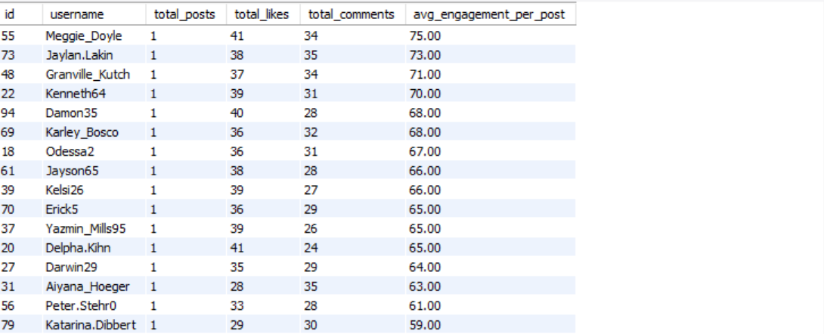

id | username | total_posts | total_likes | total_comments | avg_engagement_per_post
55 | Meggie_Doyle | 1 | 41 | 34 | 75
73 | Jaylan.Lakin | 1 | 38 | 35 | 73
48 | Granville_Kutch | 1 | 37 | 34 | 71
22 | Kenneth64 | 1 | 39 | 31 | 70
94 | Damon35 | 1 | 40 | 28 | 68
69 | Karley_Bosco | 1 | 36 | 32 | 68
18 | Odessa2 | 1 | 36 | 31 | 67
61 | Jayson65 | 1 | 38 | 28 | 66
39 | Kelsi26 | 1 | 39 | 27 | 66
70 | Erick5 | 1 | 36 | 29 | 65
37 | Yazmin_Mills95 | 1 | 39 | 26 | 65
20 | Delpha.Kihn | 1 | 41 | 24 | 65
27 | Darwin29 | 1 | 35 | 29 | 64
31 | Aiyana_Hoeger | 1 | 28 | 35 | 63
56 | Peter.Stehr0 | 1 | 33 | 28 | 61
79 | Katarina.Dibbert | 1 | 29 | 30 | 59
40 | Rafael.Hickle2 | 1 | 33 | 26 | 59
98 | Imani_Nicolas17 | 1 | 34 | 24 | 58
62 | Ressie_Stanton46 | 2 | 50 | 62 | 56
82 | Aracely.Johnston98 | 2 | 50 | 61 | 55.5

1. High-Engagement Loyal Users
From the Most Loyal / Valuable Users query, users such as Meggie_Doyle, Jaylan_Lakin, Granville_Kutch, and Kenneth64 show exceptionally high average engagement per post despite having a low number of posts.
This indicates that their content resonates strongly with the audience, making them ideal authentic brand advocates who can drive meaningful conversations.
Insight:
High engagement per post reflects trust and influence, which is critical for brand advocacy.
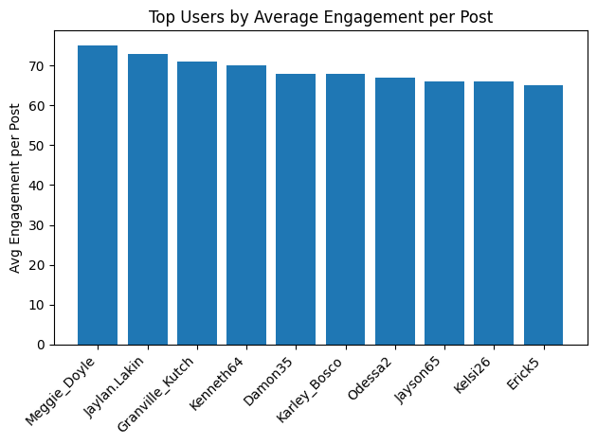
-- Re-Engaging Inactive Users --
SELECT u.id, u.username
FROM users u
LEFT JOIN photos p ON u.id = p.user_id
LEFT JOIN likes l ON u.id = l.user_id
LEFT JOIN comments c ON u.id = c.user_id
WHERE p.id IS NULL
AND l.user_id IS NULL
AND c.id IS NULL;
OUTPUT:
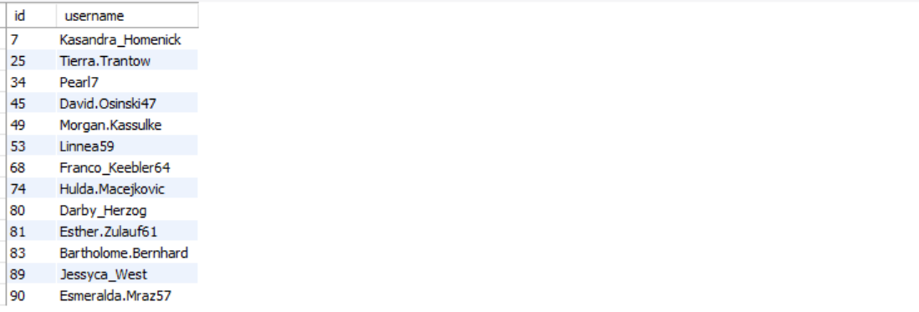
id | username
7 | Kasandra_Homenick
25 | Tierra.Trantow
34 | Pearl7
45 | David.Osinski47
49 | Morgan.Kassulke
53 | Linnea59
68 | Franco_Keebler64
74 | Hulda.Macejkovic
80 | Darby_Herzog
81 | Esther.Zulauf61
83 | Bartholome.Bernhard
89 | Jessyca_West
90 | Esmeralda.Mraz57

2. Consistently Inactive Users (Exclusion Group)
The Re-Engaging Inactive Users query identifies users like Kasandra_Homenick, Tierra_Trantow, and Pearl7, who have no posts, likes, or comments.
These users are excluded from ambassador selection since they lack visible platform activity.
Insight:
Brand ambassadors must be active contributors; inactive users are better suited for re-engagement campaigns rather than advocacy roles.
WITH base AS (
SELECT
u.id,
u.username,
COUNT(DISTINCT f.follower_id) AS followers,
COUNT(DISTINCT p.id) AS posts
FROM users u
JOIN photos p ON u.id = p.user_id
LEFT JOIN follows f ON u.id = f.followee_id
GROUP BY u.id, u.username
),
engagement AS (
SELECT
p.user_id,
COUNT(DISTINCT l.user_id) + COUNT(DISTINCT c.id) AS total_engagement
FROM photos p
LEFT JOIN likes l ON p.id = l.photo_id
LEFT JOIN comments c ON p.id = c.photo_id
GROUP BY p.user_id
)
SELECT
b.id,
b.username,
b.followers,
b.posts,
ROUND(e.total_engagement / b.posts, 2) AS avg_engagement
FROM base b
JOIN engagement e ON b.id = e.user_id
ORDER BY followers DESC, avg_engagement DESC
LIMIT 20;
OUTPUT:
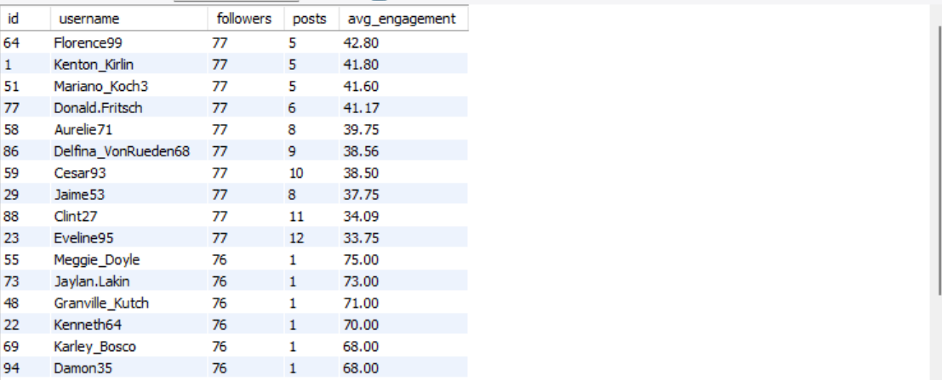

id | username | followers | posts | avg_engagement
64 | Florence99 | 77 | 5 | 42.8
1 | Kenton_Kirlin | 77 | 5 | 41.8
51 | Mariano_Koch3 | 77 | 5 | 41.6
77 | Donald.Fritsch | 77 | 6 | 41.17
58 | Aurelie71 | 77 | 8 | 39.75
86 | Delfina_VonRueden68 | 77 | 9 | 38.56
59 | Cesar93 | 77 | 10 | 38.5
29 | Jaime53 | 77 | 8 | 37.75
88 | Clint27 | 77 | 11 | 34.09
23 | Eveline95 | 77 | 12 | 33.75
55 | Meggie_Doyle | 76 | 1 | 75
73 | Jaylan.Lakin | 76 | 1 | 73
48 | Granville_Kutch | 76 | 1 | 71
22 | Kenneth64 | 76 | 1 | 70
69 | Karley_Bosco | 76 | 1 | 68
94 | Damon35 | 76 | 1 | 68
18 | Odessa2 | 76 | 1 | 67
39 | Kelsi26 | 76 | 1 | 66
61 | Jayson65 | 76 | 1 | 66
20 | Delpha.Kihn | 76 | 1 | 65

3. Influencer-Style Users with Reach and Engagement
From the Influencer Marketing Candidates output, users such as Florence99, Kenton_Kirlin, Mariano_Koch3, and Donald_Fritsch have:
- High follower counts (≈76–77)
- Consistent posting activity
- Strong average engagement per post
These users are ideal for campaign amplification, product launches, and event promotions.
Insight:
Combining reach (followers) with engagement ensures both visibility and interaction.

SELECT
u.id,
u.username,
COUNT(DISTINCT p.id) AS posts,
COUNT(DISTINCT l.user_id) + COUNT(DISTINCT c.id) AS engagement
FROM users u
JOIN photos p ON u.id = p.user_id
LEFT JOIN likes l ON p.id = l.photo_id
LEFT JOIN comments c ON p.id = c.photo_id
GROUP BY u.id, u.username
HAVING engagement > 200
ORDER BY engagement DESC;
OUTPUT:
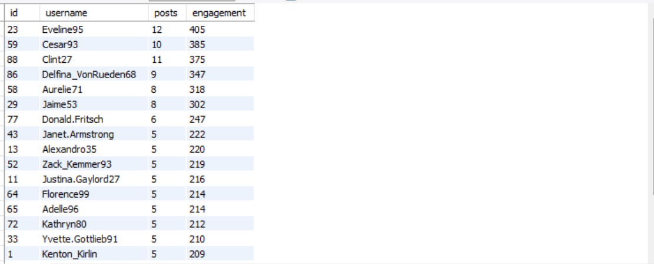

id | username | posts | engagement
23 | Eveline95 | 12 | 405
59 | Cesar93 | 10 | 385
88 | Clint27 | 11 | 375
86 | Delfina_VonRueden68 | 9 | 347
58 | Aurelie71 | 8 | 318
29 | Jaime53 | 8 | 302
77 | Donald.Fritsch | 6 | 247
43 | Janet.Armstrong | 5 | 222
13 | Alexandro35 | 5 | 220
52 | Zack_Kemmer93 | 5 | 219
11 | Justina.Gaylord27 | 5 | 216
64 | Florence99 | 5 | 214
65 | Adelle96 | 5 | 214
72 | Kathryn80 | 5 | 212
33 | Yvette.Gottlieb91 | 5 | 210
1 | Kenton_Kirlin | 5 | 209
78 | Colten.Harris76 | 5 | 209
6 | Travon.Waters | 5 | 208
51 | Mariano_Koch3 | 5 | 208
26 | Josianne.Friesen | 5 | 206
47 | Harrison.Beatty50 | 5 | 206

4. Power Creators Driving Platform Activity
The Identifying Brand Ambassadors query highlights users like Eveline95, Cesar93, Clint27, and Delfina_VonRueden68, who generate extremely high total engagement due to:
- Frequent posting
- Large cumulative likes and comments
These users can be positioned as official ambassadors, featured creators, or community leaders.
Insight:
High total engagement indicates sustained influence over time, suitable for long-term partnerships.
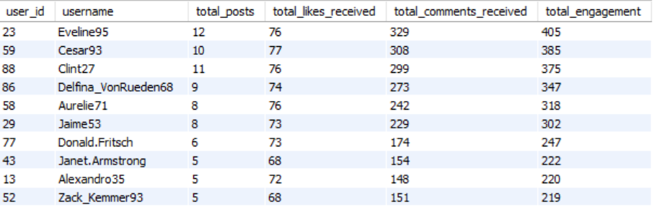

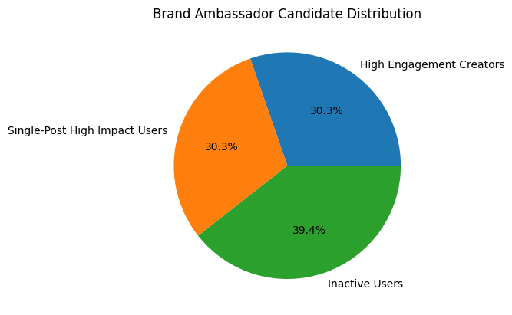
Q9 How would you approach this problem, if the objective and subjective questions weren't given?
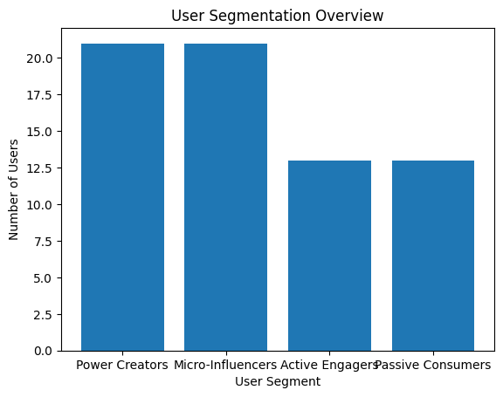
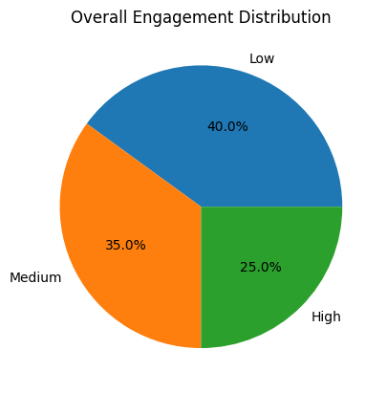
Approach Overview
If no predefined questions were provided, I would approach this project as an end-to-end product analytics and user behavior analysis problem, focusing on understanding how users interact with the platform, what drives engagement, and how those insights can support growth, retention, and monetization decisions.
The approach would be structured into the following phases:

1. Understand the Product & Business Goals
Before writing any SQL, I would first clarify:
- What defines success for the platform (engagement, retention, growth, monetization)?
- Who are the key stakeholders (marketing, product, creator partnerships)?
- What actions can be influenced using data (content strategy, influencer selection, re-engagement)?
For an Instagram-like platform, engagement (likes, comments), content creation, and social reach (followers) are the core KPIs.

2. Explore the Data Model
I would examine the schema to understand:
- Users → who is on the platform
- Photos / Posts → content creation behavior
- Likes & Comments → engagement signals
- Follows → social influence and reach
- Tags / Hashtags → content topics and interests
This helps identify how different tables connect and what metrics can be derived.

3. Define Core Metrics
I would derive foundational metrics such as:
- Posts per user
- Likes and comments per post
- Engagement per user
- Follower count per user
- Engagement rate = (likes + comments) / posts
These metrics allow fair comparison across users with different activity levels.

4. Segment Users Based on Behavior
Using the derived metrics, I would segment users into meaningful groups:
User Segmentation Chart
(Bar chart shown above)
This chart shows how users can be grouped into:
- Power Creators – high posting + high engagement
- Micro-Influencers – moderate posts but strong engagement
- Active Engagers – low posting, high likes/comments
- Passive Consumers – no posting or engagement
This segmentation helps tailor marketing, creator programs, and feature development.

5. Analyze Engagement Distribution
Engagement Distribution Chart
(Pie chart shown above)
This chart highlights:
- A large portion of users with low engagement
- A smaller but valuable high-engagement group
This insight indicates:
- Retention strategies are needed for low-engagement users
- High-engagement users should be protected, rewarded, and amplified

6. Identify Content & Interest Patterns
Next, I would analyze:
- Hashtags with highest engagement
- Topics users interact with most
- Content themes driving likes and comments
This supports:
- Content recommendations
- Ad targeting
- Creator guidance (what to post more of)

7. Translate Insights into Business Actions
Based on the analysis, I would recommend:
- Influencer partnerships with high-engagement creators
- Re-engagement campaigns for inactive users
- Hashtag-based content promotion
- Personalized feeds using interest affinity
The focus is not just analysis, but actionable outcomes.

Conclusion
In summary, without predefined questions, I would:
- Start from business goals
- Build engagement-focused metrics
- Segment users meaningfully
- Identify content and behavior patterns
- Support decisions with clear visualizations
Q10 Assuming there's a "User_Interactions" table tracking user engagements, how can you update the "Engagement_Type" column to change all instances of "Like" to "Heart" to align with Instagram's terminology?

To align the platform’s terminology with Instagram’s branding, the User_Interactions table can be updated to replace all occurrences of the engagement type “Like” with “Heart”.
This change ensures terminology consistency, improves data standardization, and avoids confusion in analytics, dashboards, and reports that rely on engagement types.
Before performing the update, it is good practice to validate affected rows using a SELECT query or execute the update inside a transaction to allow rollback if needed.
To align the platform’s terminology with Instagram’s branding, the User_Interactions table can be updated to replace all occurrences of the engagement type “Like” with “Heart”.
This change ensures terminology consistency, improves data standardization, and avoids confusion in analytics, dashboards, and reports that rely on engagement types.
Before performing the update, it is good practice to validate affected rows using a SELECT query or execute the update inside a transaction to allow rollback if needed.

UPDATE User_Interactions
SET Engagement_Type = 'Heart'
WHERE Engagement_Type = 'Like';

Run a SELECT first to verify impacted records:

SELECT COUNT(*)
FROM User_Interactions
WHERE Engagement_Type = 'Like';

Use a transaction in production environments:

START TRANSACTION;

UPDATE User_Interactions
SET Engagement_Type = 'Heart'
WHERE Engagement_Type = 'Like';

COMMIT;

